Infrastructure Repository and Pipeline

Content

1. Initialize the repository 2

2. Set up the variable group 5

3. Set up and run the pipeline 8

1. Initialize the repository
   1. Navigate to your repository in your project

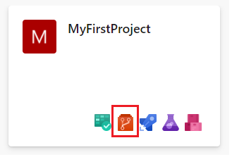

* 1. Initialize your repository with a generic readme file by clicking on Initialize

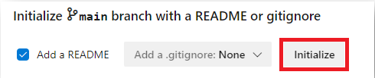

* 1. Add a new file to your repository

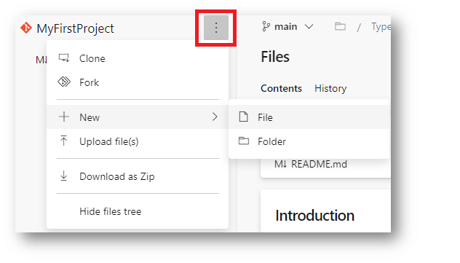

* 1. Give it a meaningful name with the suffix .yml

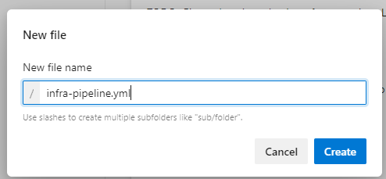

* 1. Now start writing the infrastructure pipeline to deploy an **App Service Plan** and a **WebApp** in Azure step by step

*Warning: The formatting of YAML (yml) files is based on spaces and tabs and therefor the following lines should be copied with care.  
It is advised to use Visual Studio Code to validate the copied file.*

Starting with making the variable group available to the pipeline. From now on we can reference any variable that is held in the variable group under libraries (described under 2):

variables:  
- group: infravars

Next, we need to set a trigger which will run the pipeline after every commit on this repository:  
(we set it to none to avoid unwanted pipeline runs)  
  
trigger: none  
  
Then we need to set an operating system in which our pipeline will run:

pool:  
 vmImage: ubuntu-latest  
  
After that we define the smallest building block of a pipeline which is called **step** and

can be a task or a script.

This Task that we want to use is a special Azure CLI task that will execute our commands like would do it on the Azure Portal in the cloud shell:

steps:

- task: AzureCLI@2

inputs:

azureSubscription: '$(so)'

scriptType: 'bash'

scriptLocation: 'inlineScript'

inlineScript: |

az appservice plan create -g $(rg) -n $(asp) --is-linux --number-of-workers 1 --sku B1

az webapp create -g $(rg) -p $(asp) -n $(wa) --runtime "node|10.14"

If you want to learn more about the concept of a pipeline you can do it here:  
  
https://docs.microsoft.com/de-de/azure/devops/pipelines/get-started/key-pipelines-concepts?view=azure-devops

1. Set up the variable group
   1. Navigate to Libraries

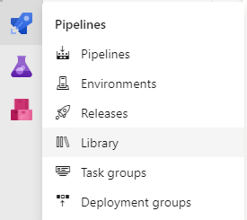

* 1. Click on Variable group

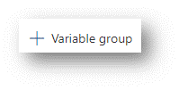

* 1. Name it **infravars** and define the variables that you want to use at the pipeline

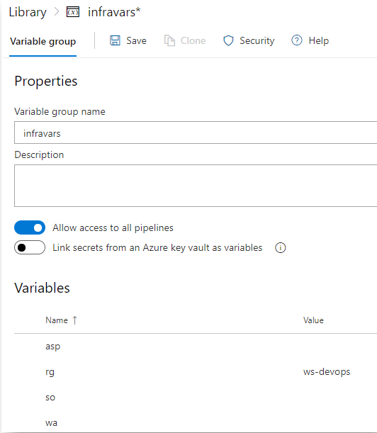

We all are use the same Subscription and same Resource Group but

everybody uses his own App Service Plan and his own Webapp.

Therefore, pick unique names e.g. robsplan21 or robswebapp21 for your App Service Plan

and Webapp variables.

Use for Resource Group (rg) **ws-devops**.

asp = App Service Plan must be unique in each resource group (your own)  
rg = Resource Group must be unique in each subscription **(**use **ws-devops)**  
so = Service Connection Name which you have set in your project (Settings -> Service connections)

wa = Webapp must be unique worldwide (your own)

Of course, you can use your own variables names, they must correspond with your pipeline.

1. Set up and run the pipeline  
   1. Now it is time for some rocket science, therefore click on the rocket and reference it to your pipeline

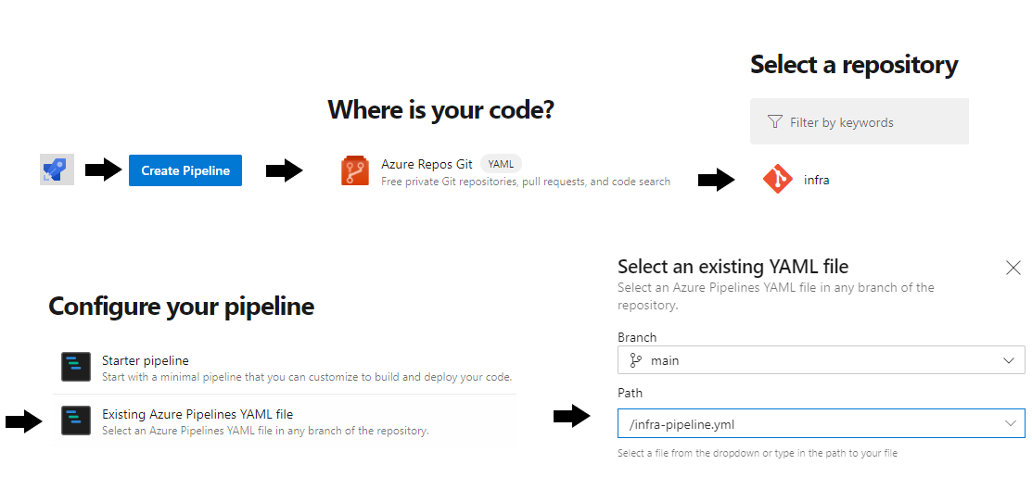

* 1. After all you can admire your work and launch the pipeline by clicking on RUN (upper right corner)

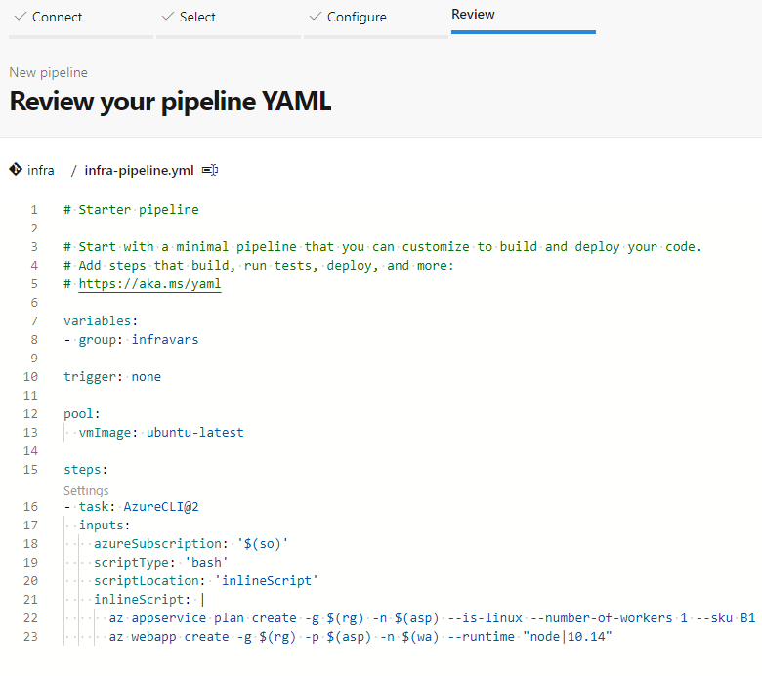

* 1. Now you can watch your pipeline running by clicking on the Job

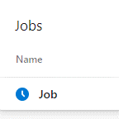

* 1. After the pipeline has run you should see only green lights

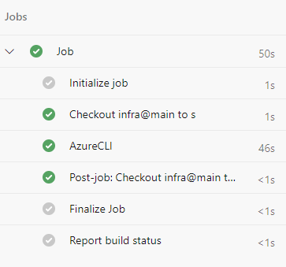

* 1. Check your WebApp is online after approx. 5 minutes

https://<yourWebAppName>.azurewebsites.net/

You should see a “Hey, Node developers” welcome screen.

Congratulations, you have deployed your first WebApp infrastructure.   
Now, you can go ahead and deploy some code to your WebApp.

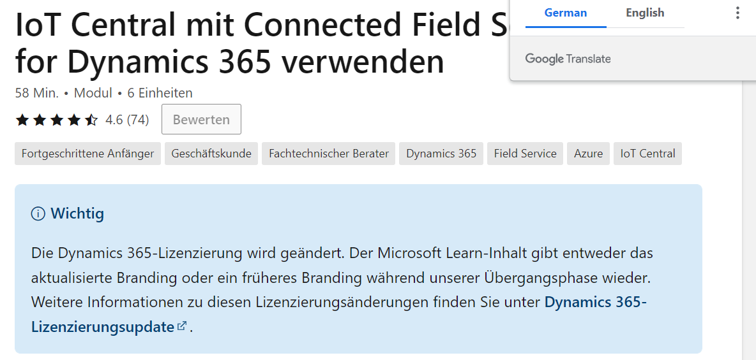

Wo ist die sap on top sap Leonardo

Sap verbindung on prem

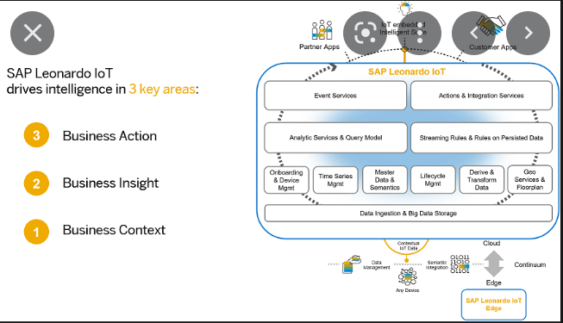

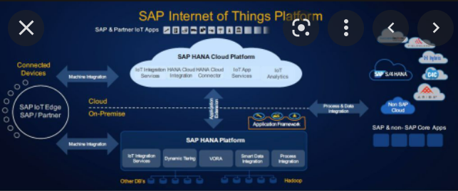

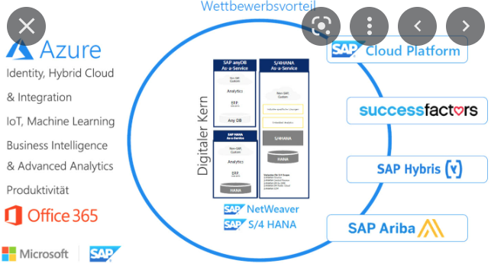

Kann ich sap an ein bussystem anschließen; wie ist die output seite von SAP

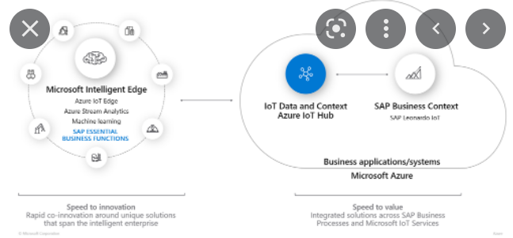

Microsoft und SAP haben die allgemeine der Verfügbarkeit Integration von SAP Leonardo IoT mit Azure IoT Hub verkündet. Kunden sollen damit die Daten von IoT-Sensoren und anderen Endgeräten im Internet der Dinge in die Business-Anwendungen von SAP übertragen und dort verarbeiten können. Im [Rahmen des Mobile World Congress](https://www.heise.de/meldung/SAP-und-Microsoft-kuendigen-Partnerschaft-fuer-das-Internet-der-Dinge-an-4319847.html) hatten beide Unternehmen bereits die geplante Integration angekündigt, seinerzeit jedoch noch ohne festen Fahrplan.

Konkret können Kunden aus der Microsoft Cloud auf die Angebote Azure IoT Hub und Azure IoT Edge zugreifen. Ersteres ist eine zentrale Stelle zum Verwalten der IoT-Endgeräte. Letzteres dient dem Bereitstellen von containerisierten Diensten auf den Endgeräten. Auf die Weise lassen sich Daten direkt am Edge verarbeiten und auswerten beziehungsweise für die Weiterverarbeitung in der Cloud vorbereiten.

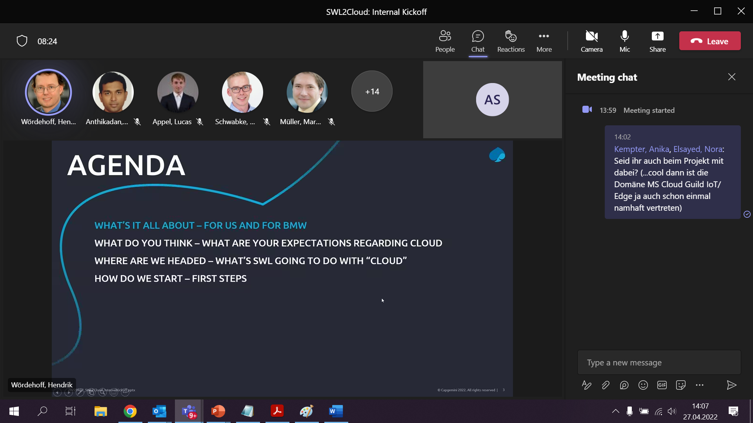

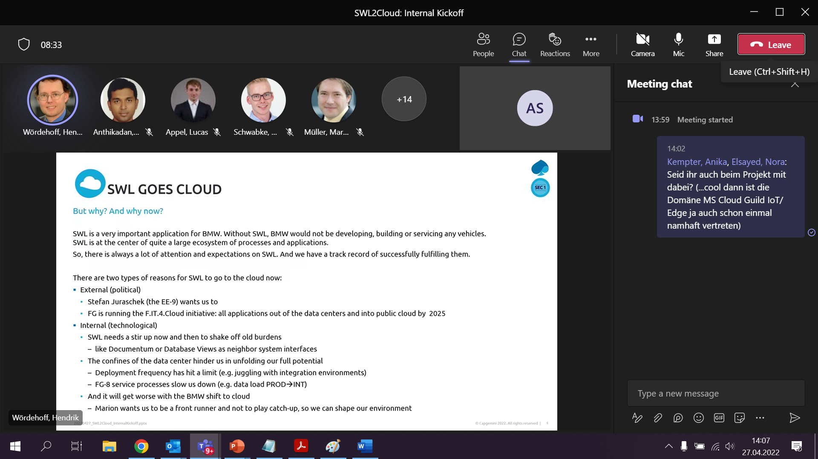

2 days without

High expectation 2025

* Problem many interfaces
* Documentum
* How many environments (Too few/ Too many)

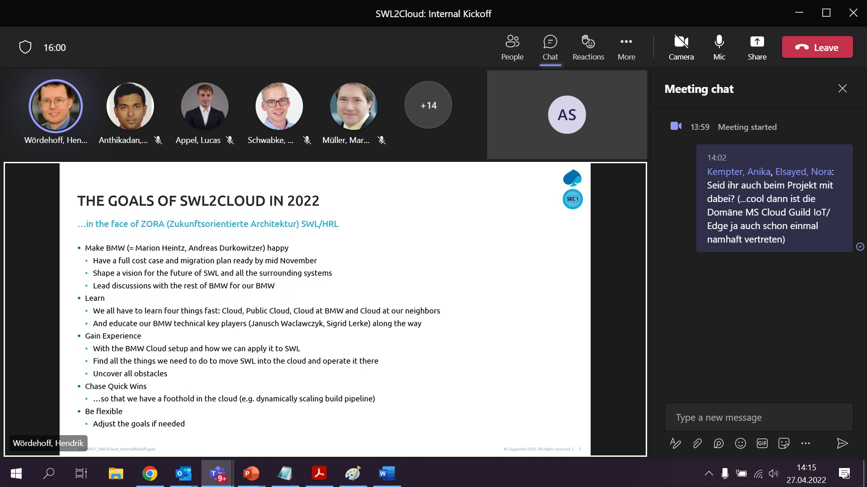

Have a full cost

* What are the cost => so far fix

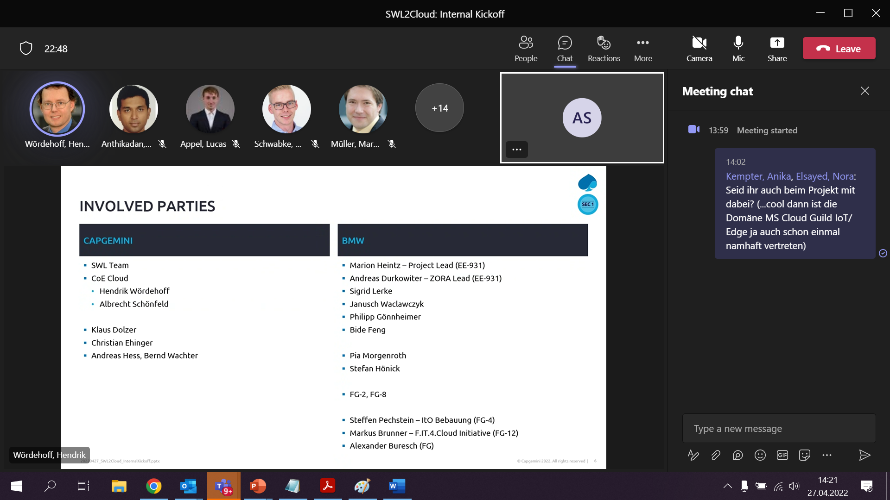

Stefan Hönick => Hochregallager

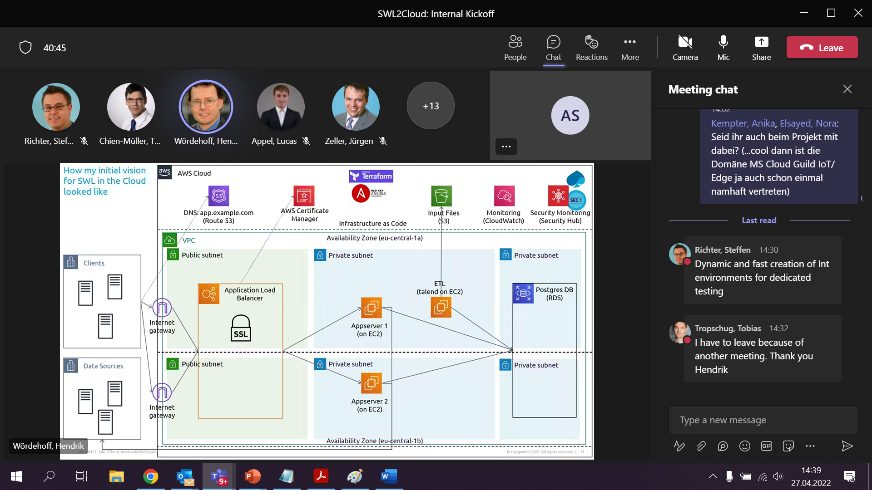

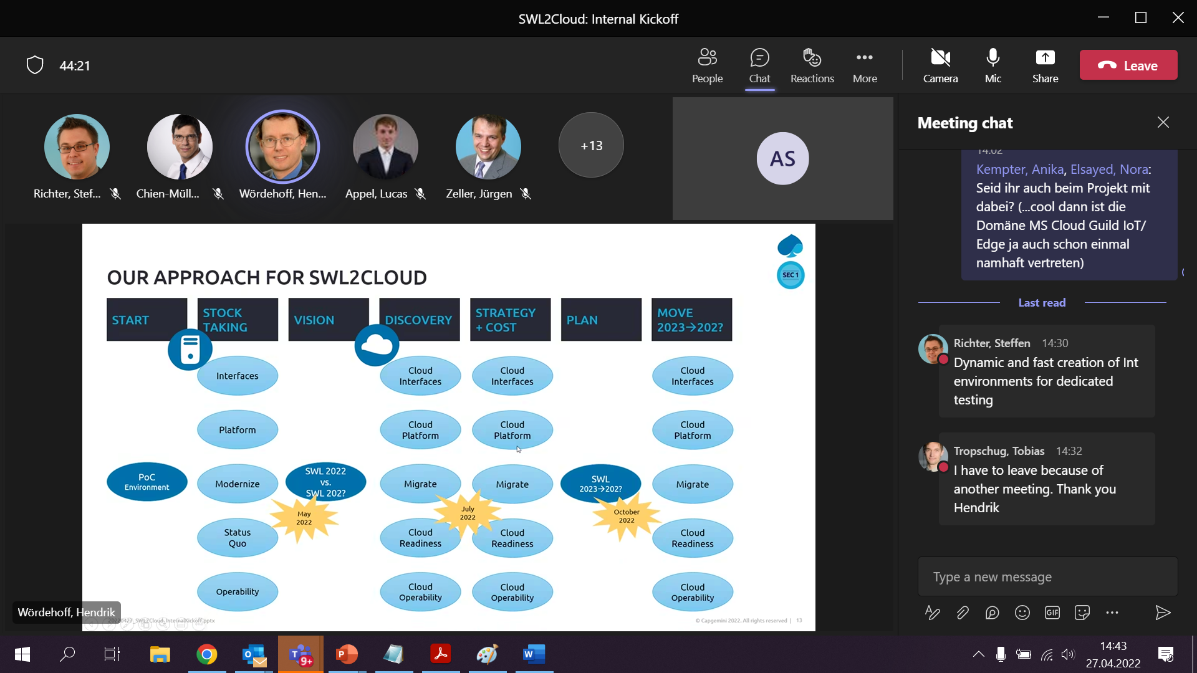

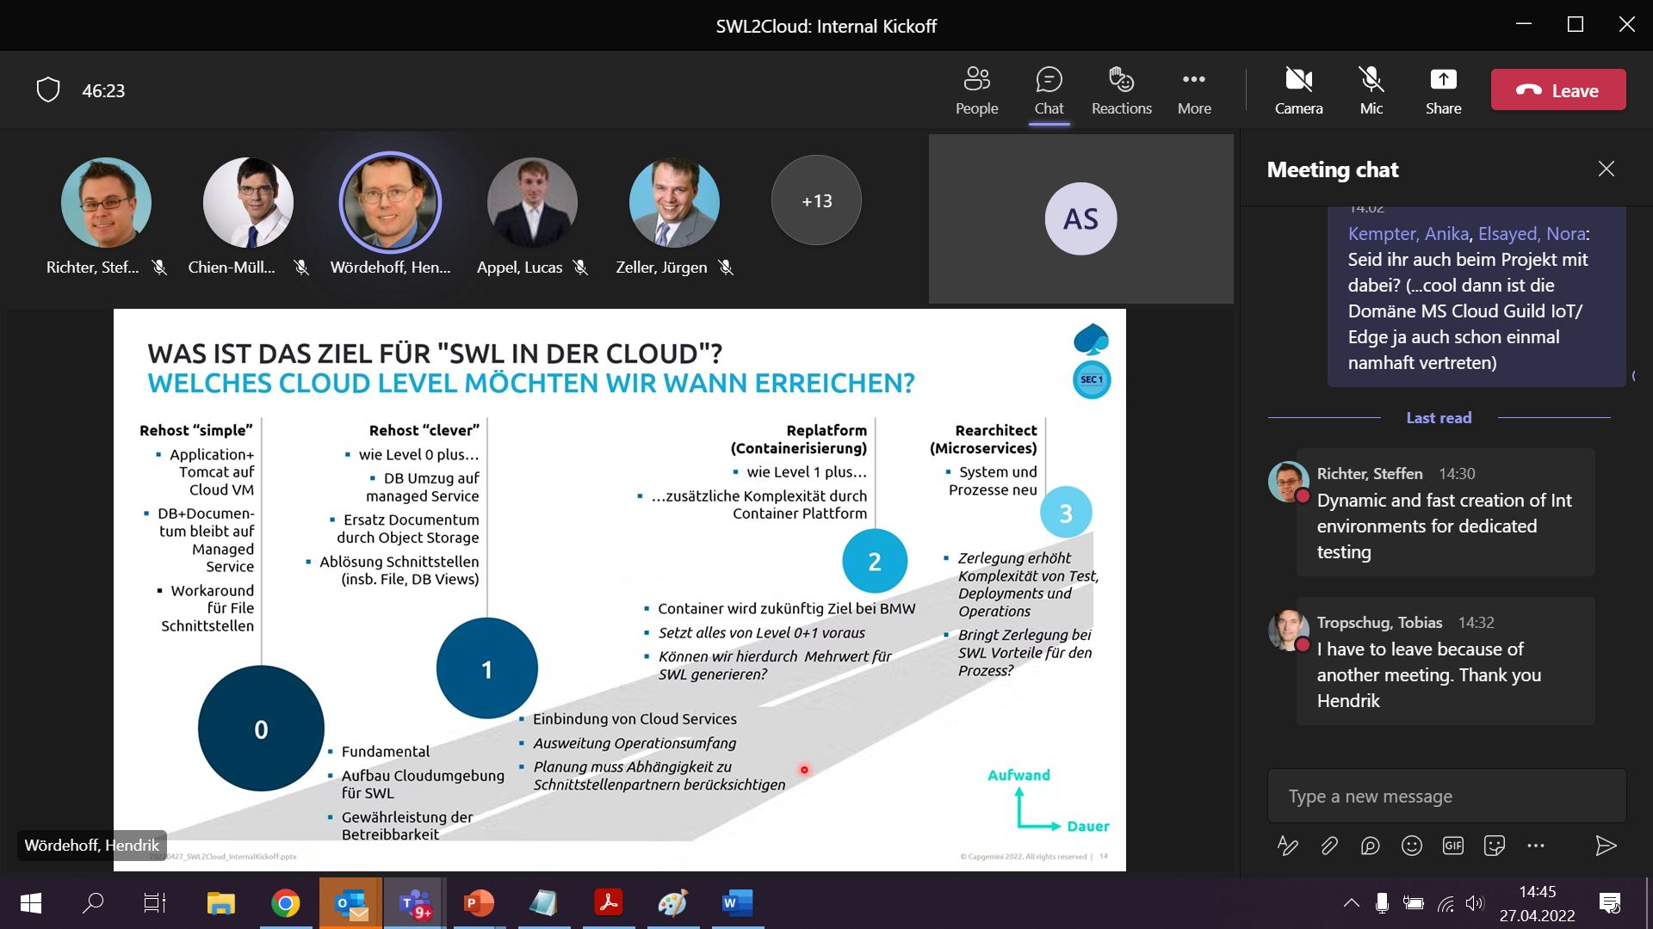

What we go for is 1

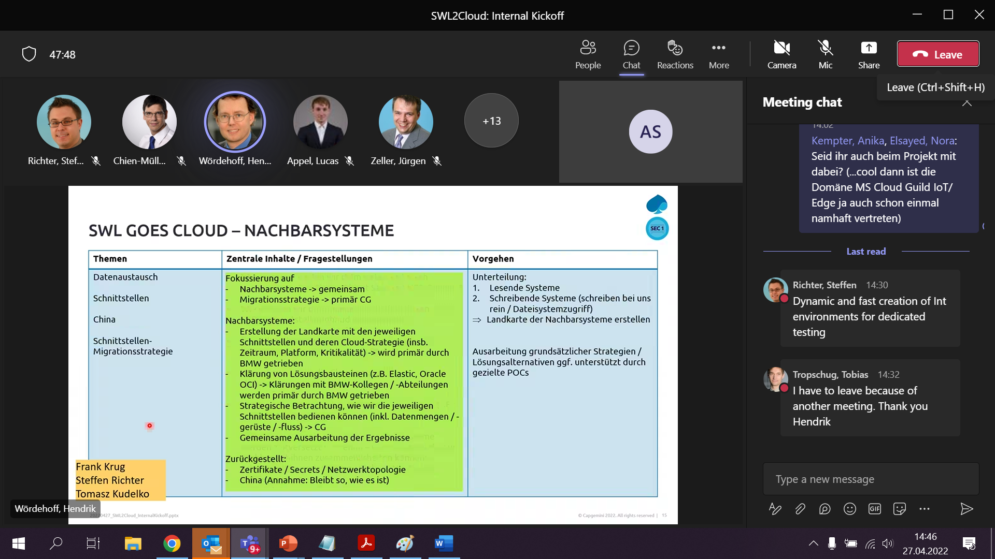

70 Interfaces (Database Views)

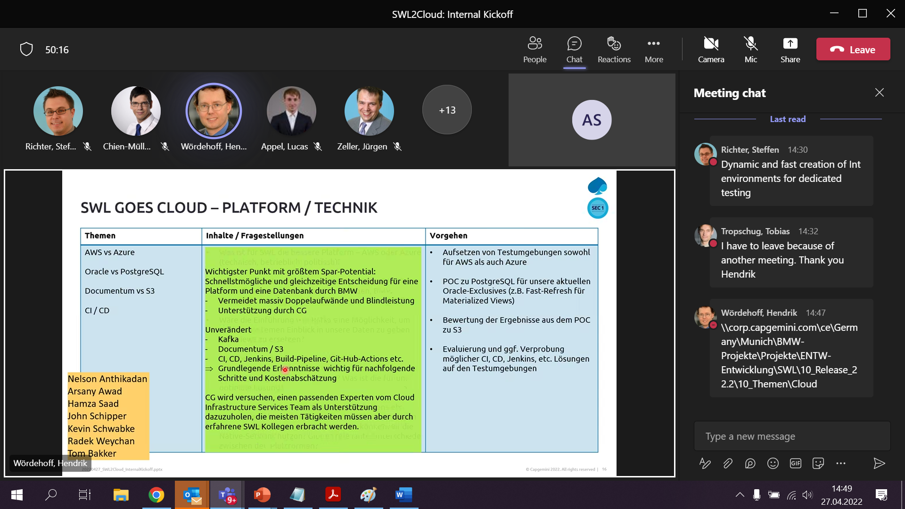

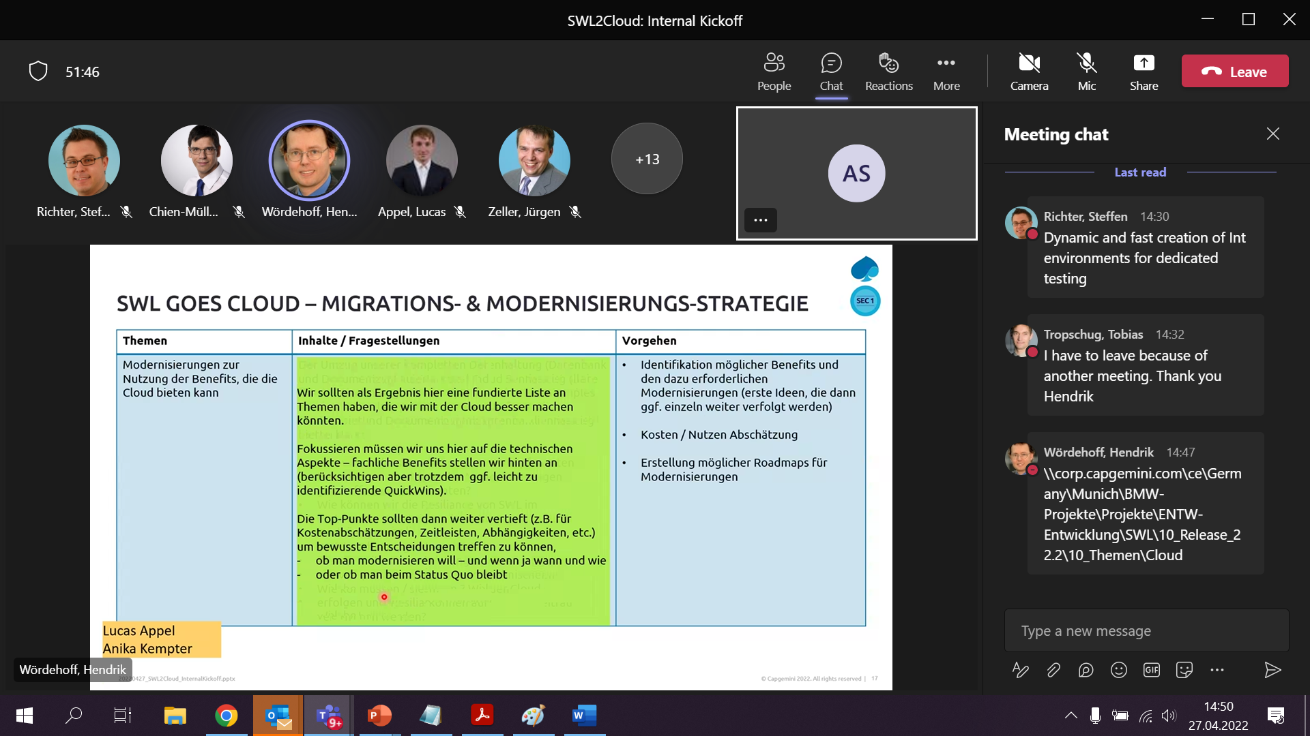

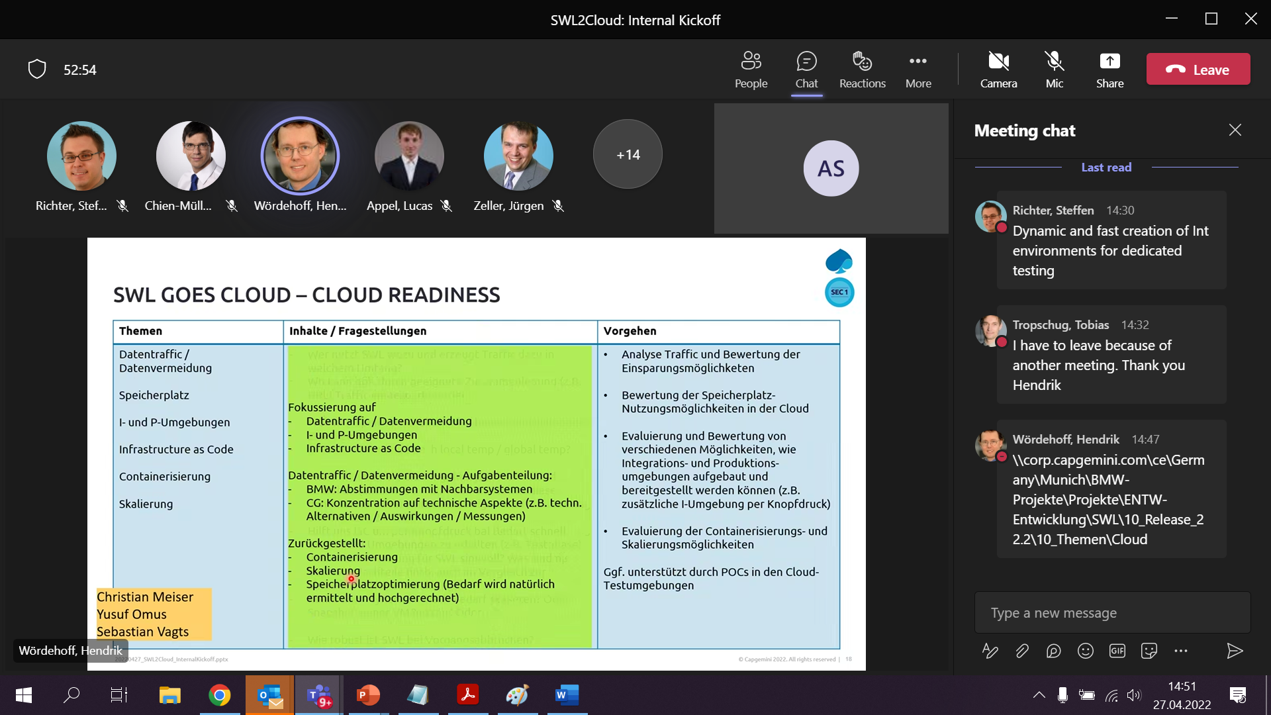

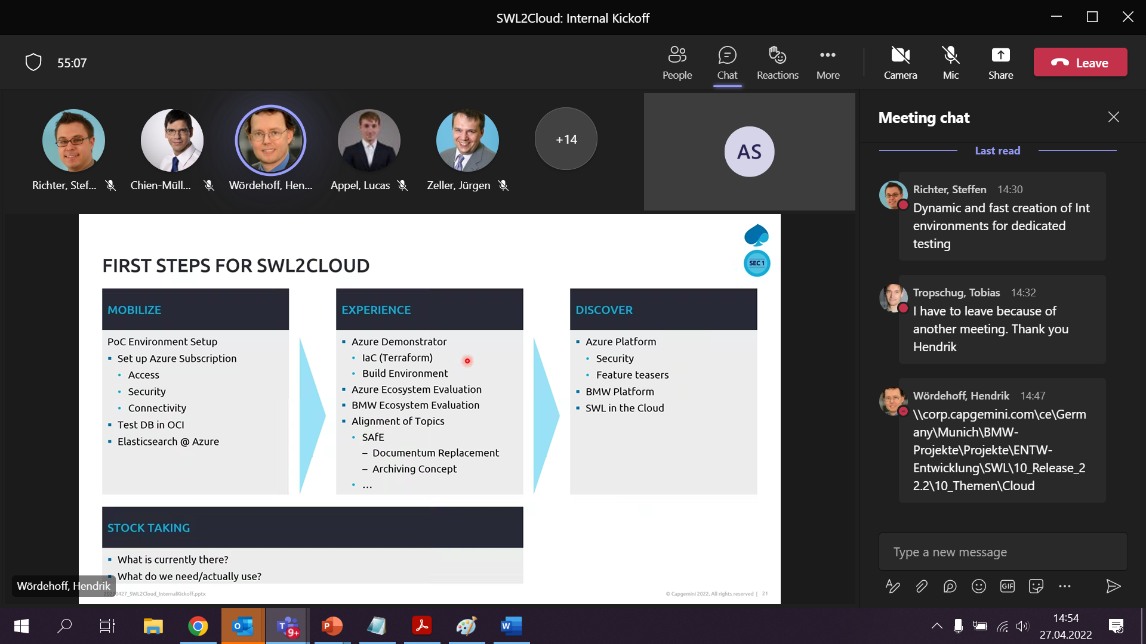

Mai

* Set up subscription

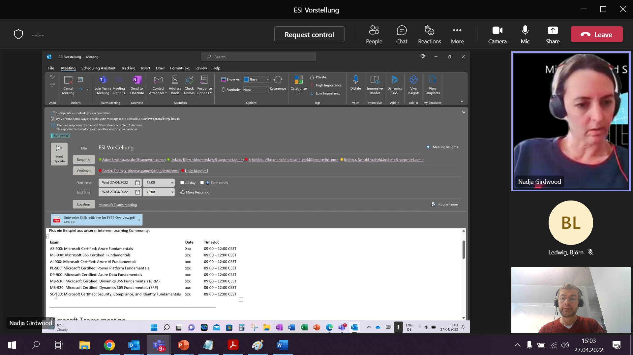

Prep session 3h

Azure

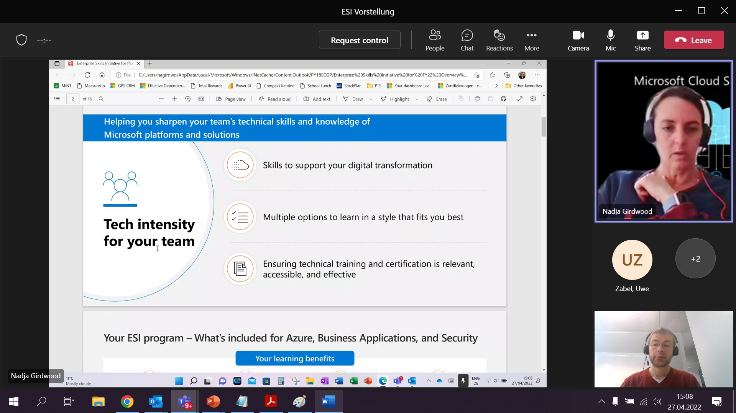

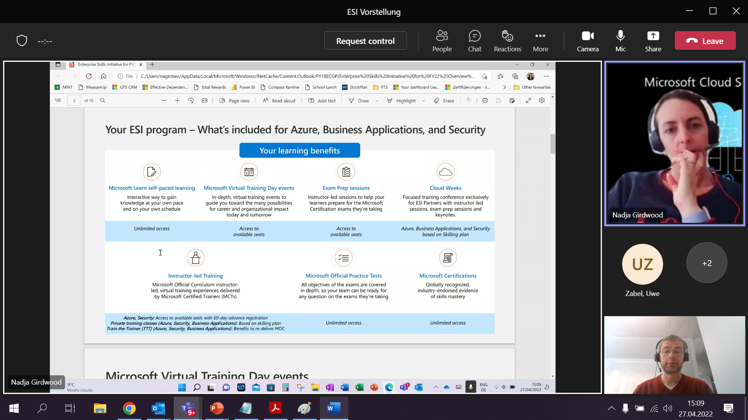

Esi calendar

Cloud weeks nur für den Partner

* Global austausch
* Games
* Melinda Crohn

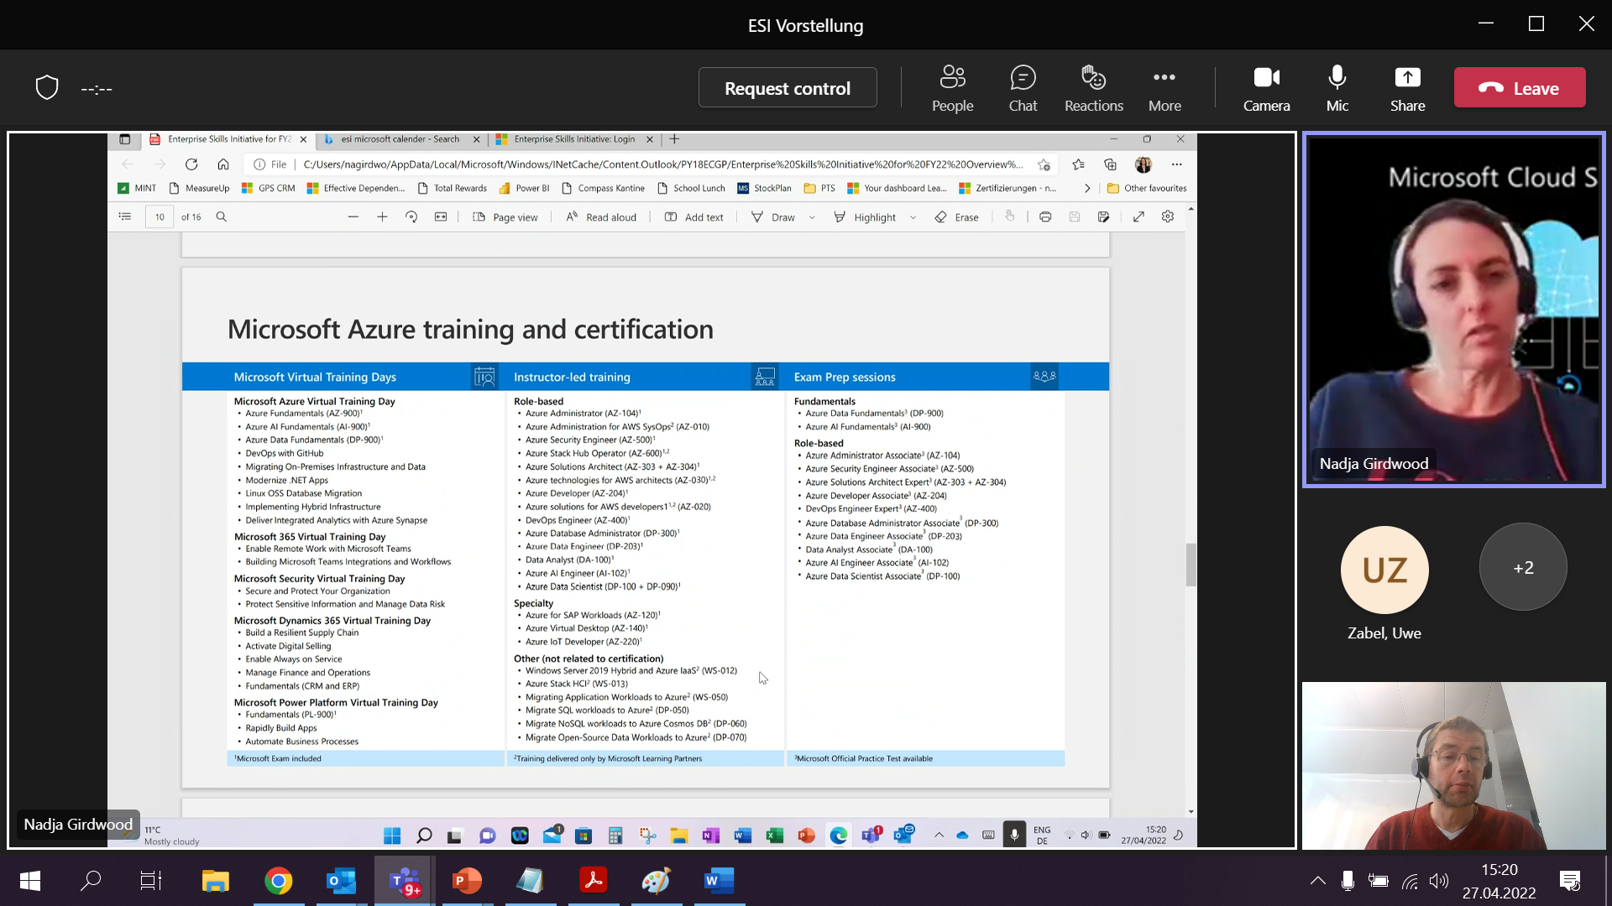

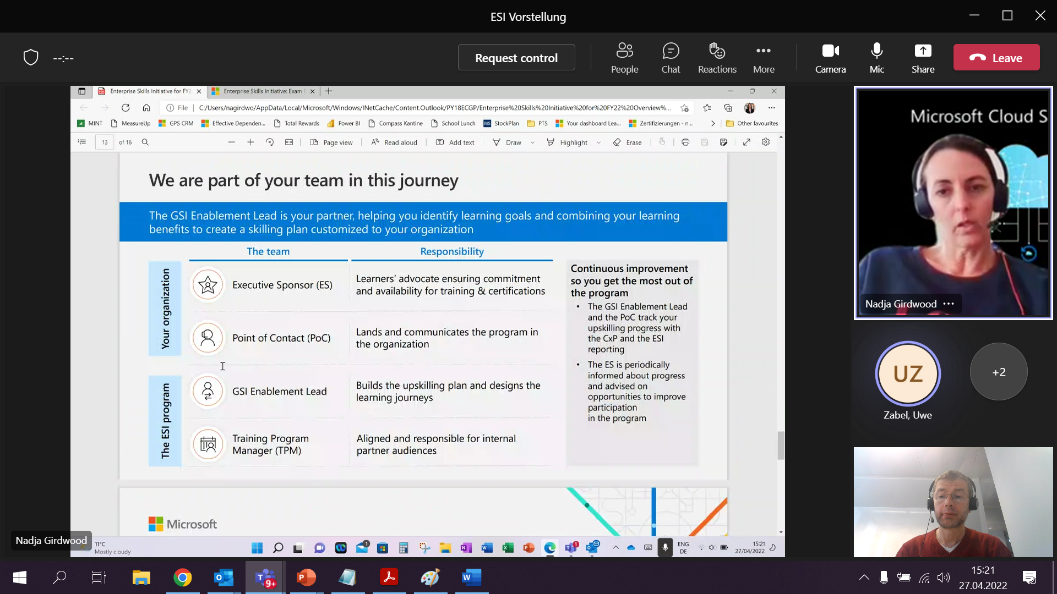

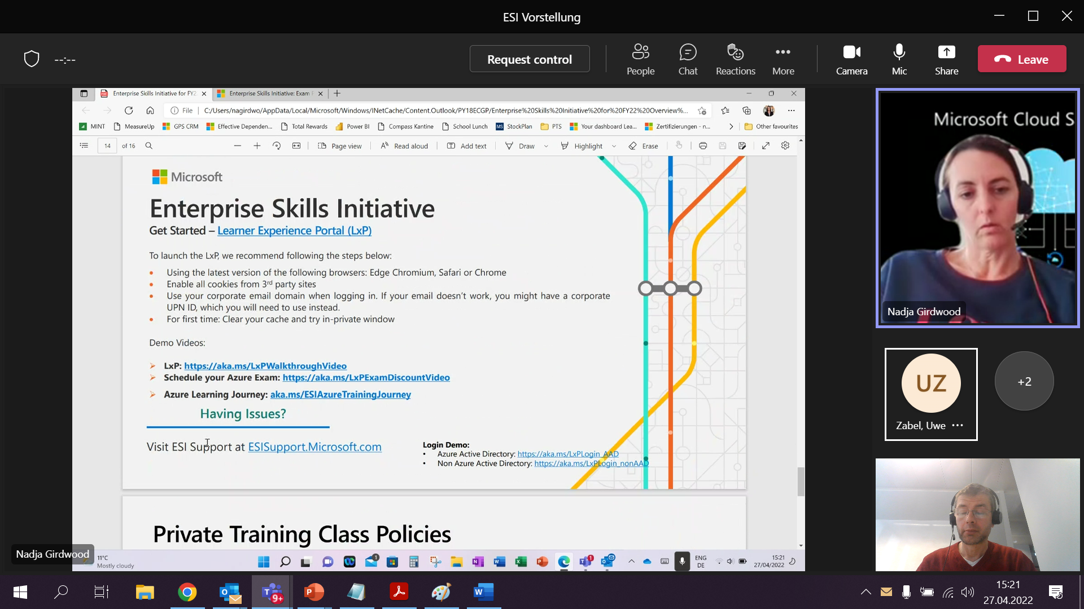

Dear Members & IoT/ Edge Enthusiasts,

below the summary of our relaunch. Meetings will be always in English so that also non-German speakerscan follow. Below you find the most important links for our daily work:

* **Our Home**

Link to the IoT/ Edge Channel within the Microsoft Cloud Guild (=our home):

* **Channel in teams to our recordings**

Of course you also find the recording of our relaunch there.

NOTE: If you are a member you should automatically access. If you are not a member there are two options: (1) fill out the registration form or (2) contact Julian or me to give you permissions

* **Link to Backlog**

As mentioned feel free to add or to vote for a certain topic.

* **Regarding your suggestions**

Let me quickly add a few points:

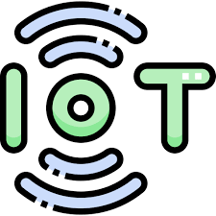

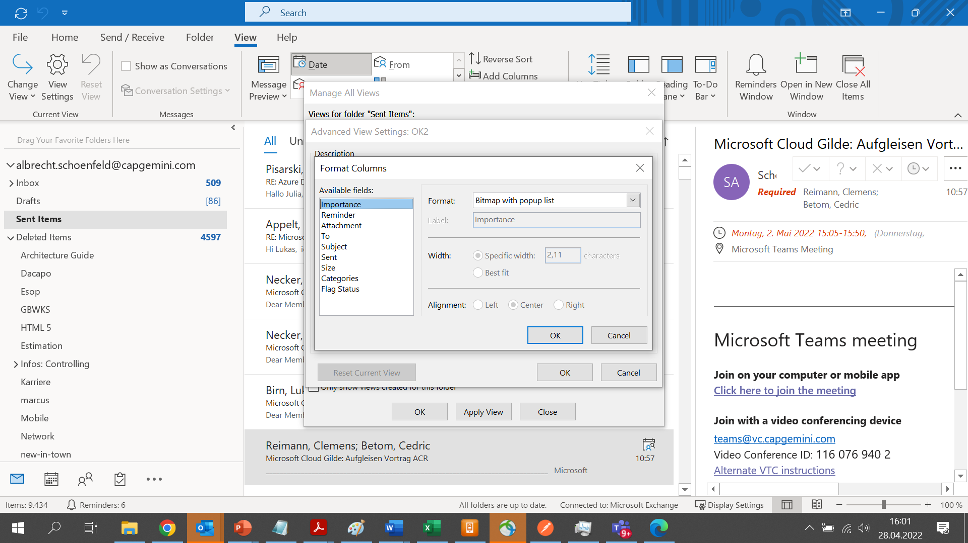

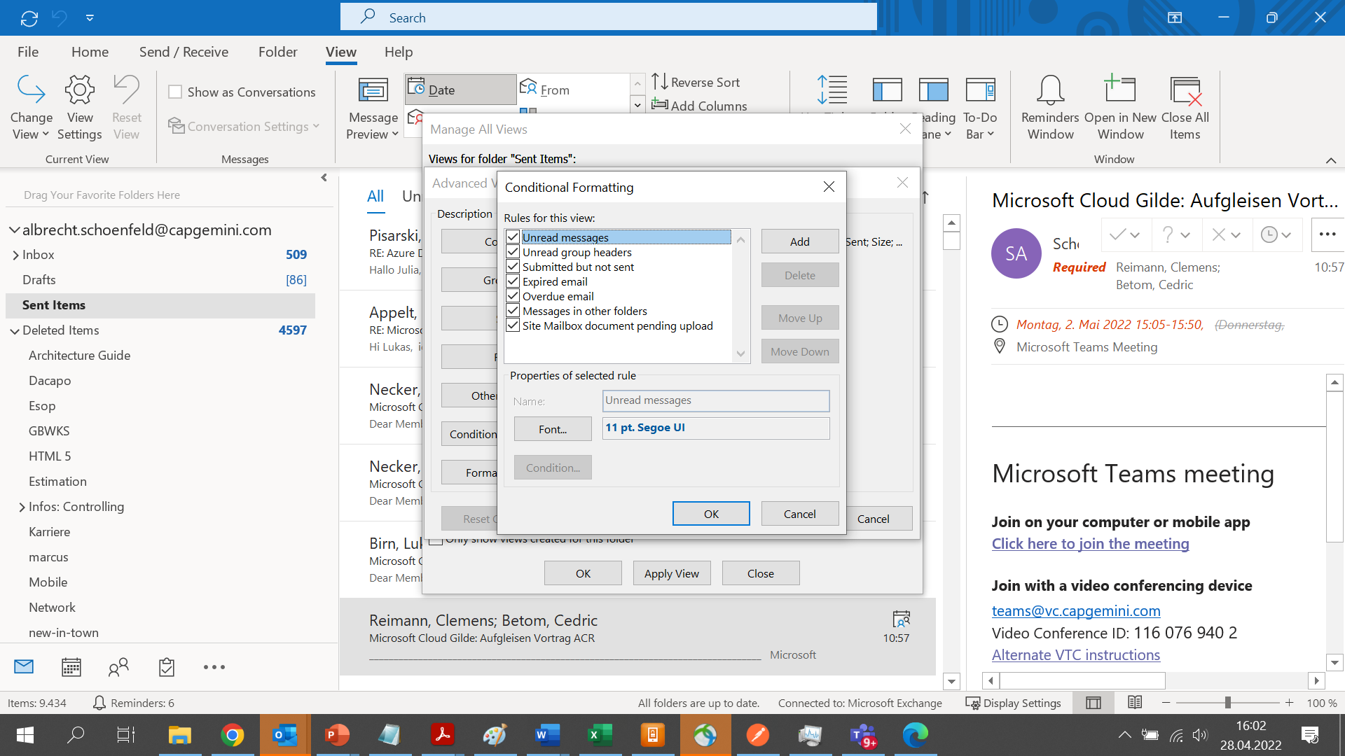

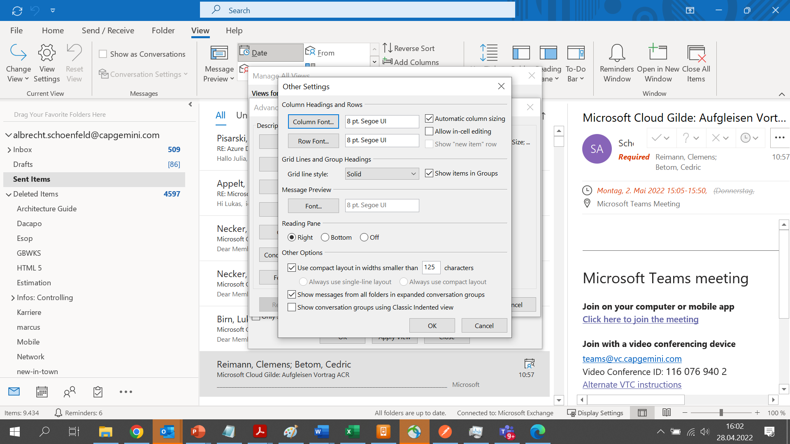

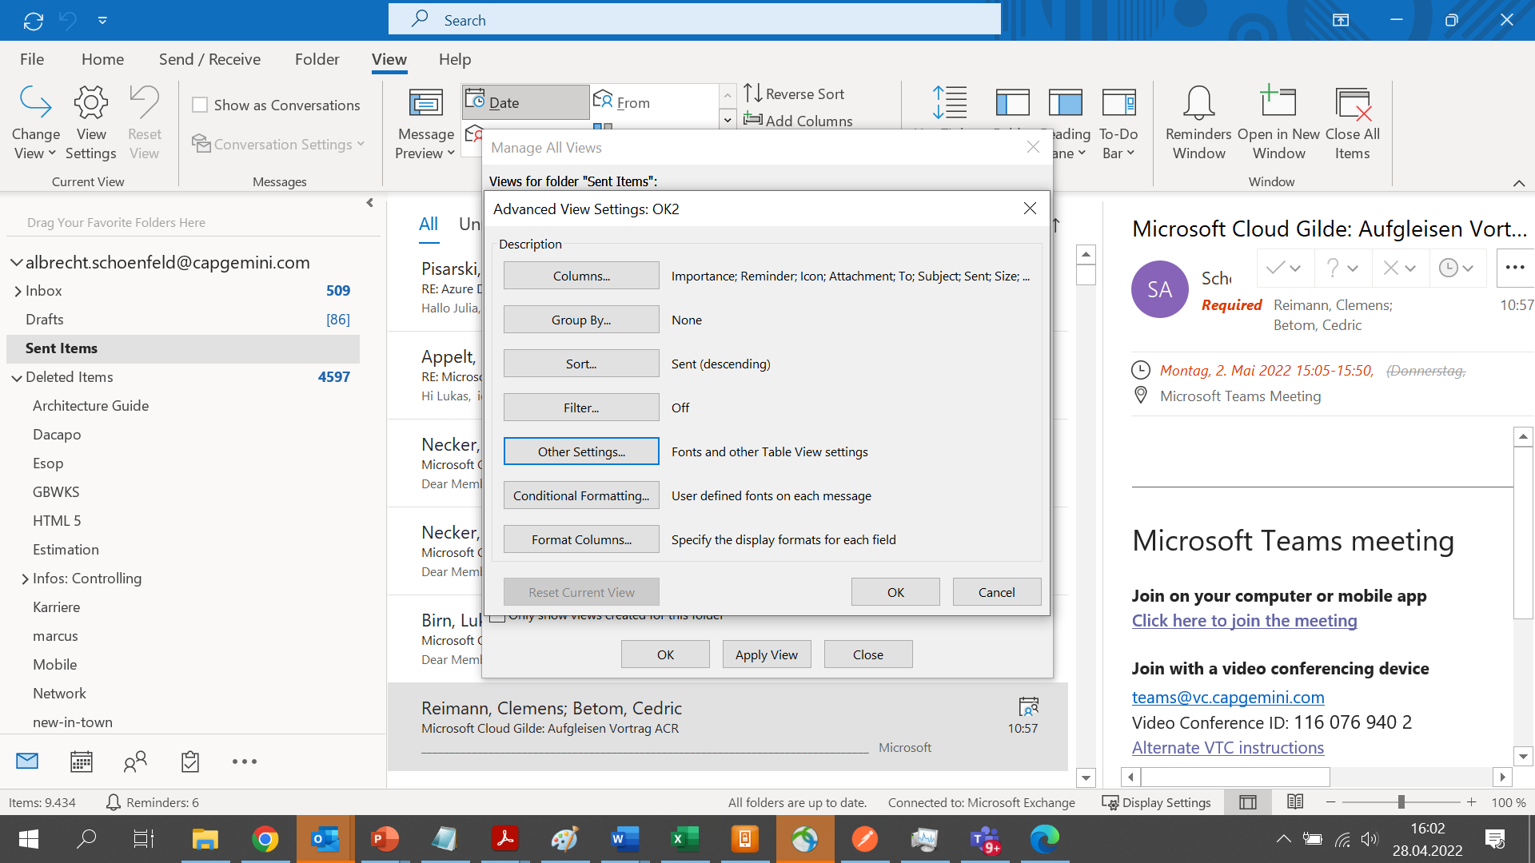

Scope Meine Aufgabe

* Welche Tiers sollen in die Cloud
  + Presentation ==> haben wir dies überhaupt?
  + Business Logic ==> Welche Plattform
  + Database ==> Klar OCI
* Zugriff on-premise/ entwickler/ BMW Azure

Planung für den Umzug/ Kostenschätzung

Martin Müller will das BMW Team qualifizieren

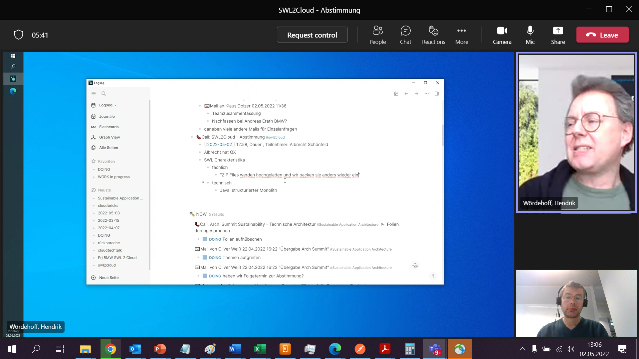

1 Komponentencontainer

* Bootloader
* Verschiedene SWEinheiten
* Kennlinienfeldern
* Sprachpakete

Navidaten

Historie

* Update von einem älteren Stand
* Geht dies überhaupt

Freigabeprozesse

* In Verbindung mit folgenden Steuergeräten

Out: Standalone Datenbank; I-Stufen Container (=Release) (Serien sind die Hauptreleases; mehrstufig = 1. Festlegung welche Protokolle; 2. Fertig zum Rollout)

Nicht jeder darf alles sehen (z.B. nicht freigegeben nur von BMW interne); BMW Rollen + Rechte habe ich Zugang oder nicht

Documentum

* Dateien mit Schlagworten + Verlinkungen

Jobs für I stufen/ DB dauert eine Weile

Swing => Fat Client; JEEE; Awendungsserver

Nachbarsysteme

Andere Umgebungen (Buildserver, Log Files Elastic Search)

2 Linien (Planung nächstes Jahr; PoC aktuelle Schiene;;; was kann man besser machen)

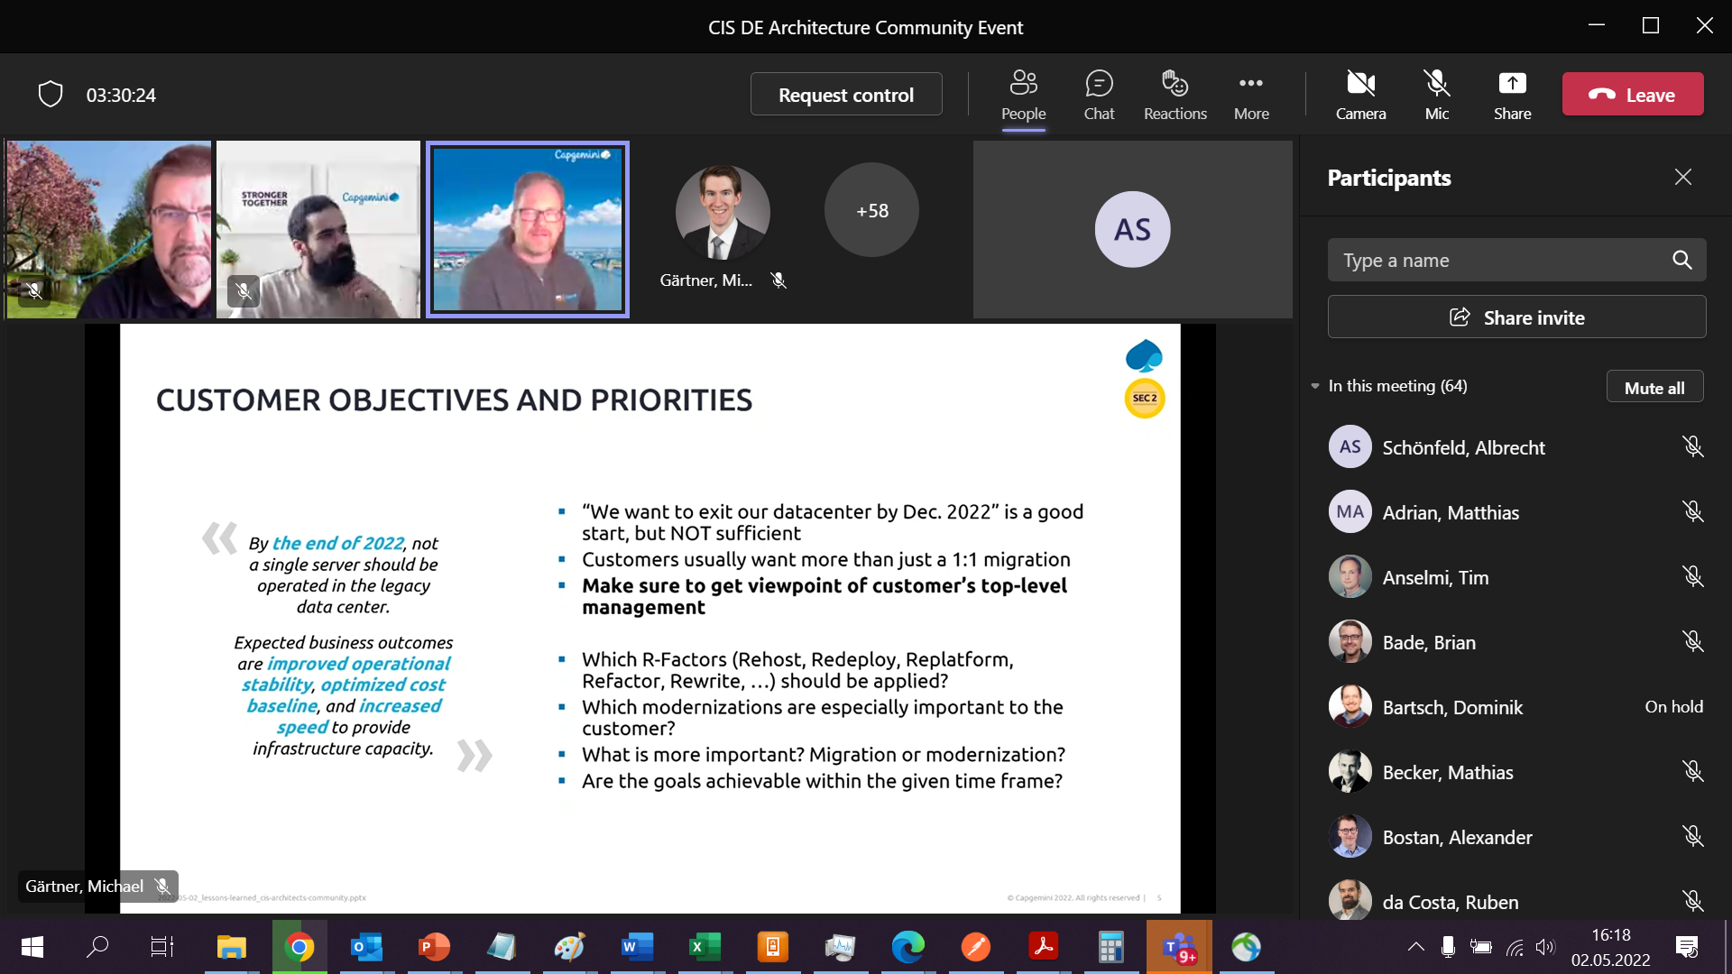

Erst in die Cloud weil mehr Möglichkeiten zu modernisieren

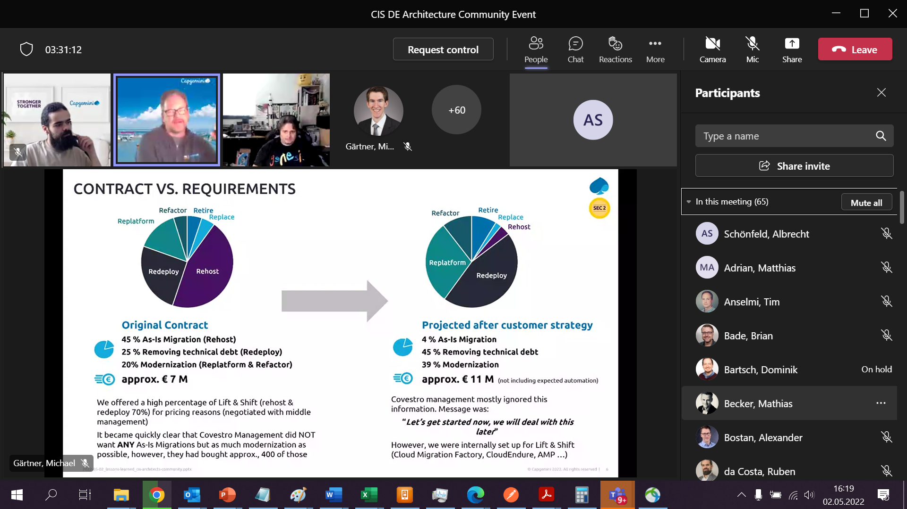

Kunde sagt ich will gleich modernisieren

Must know when to use

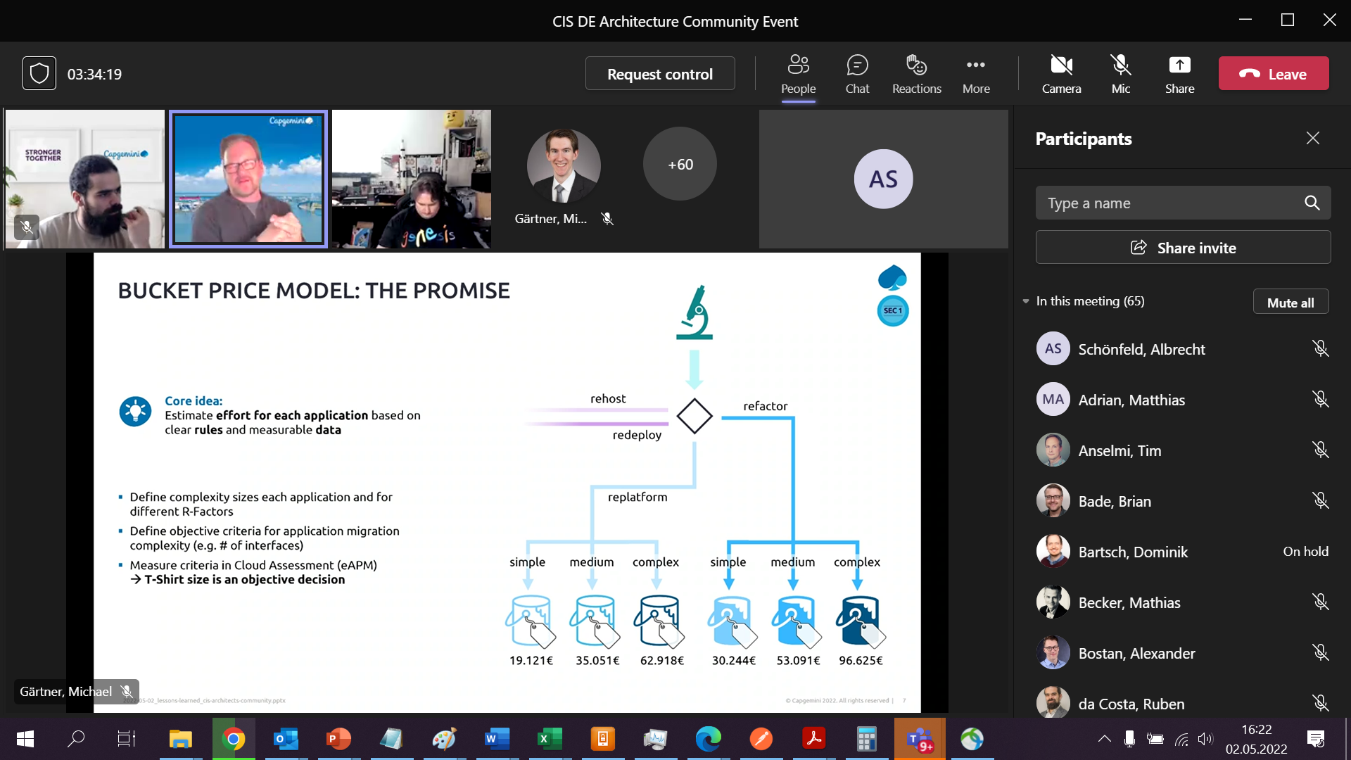

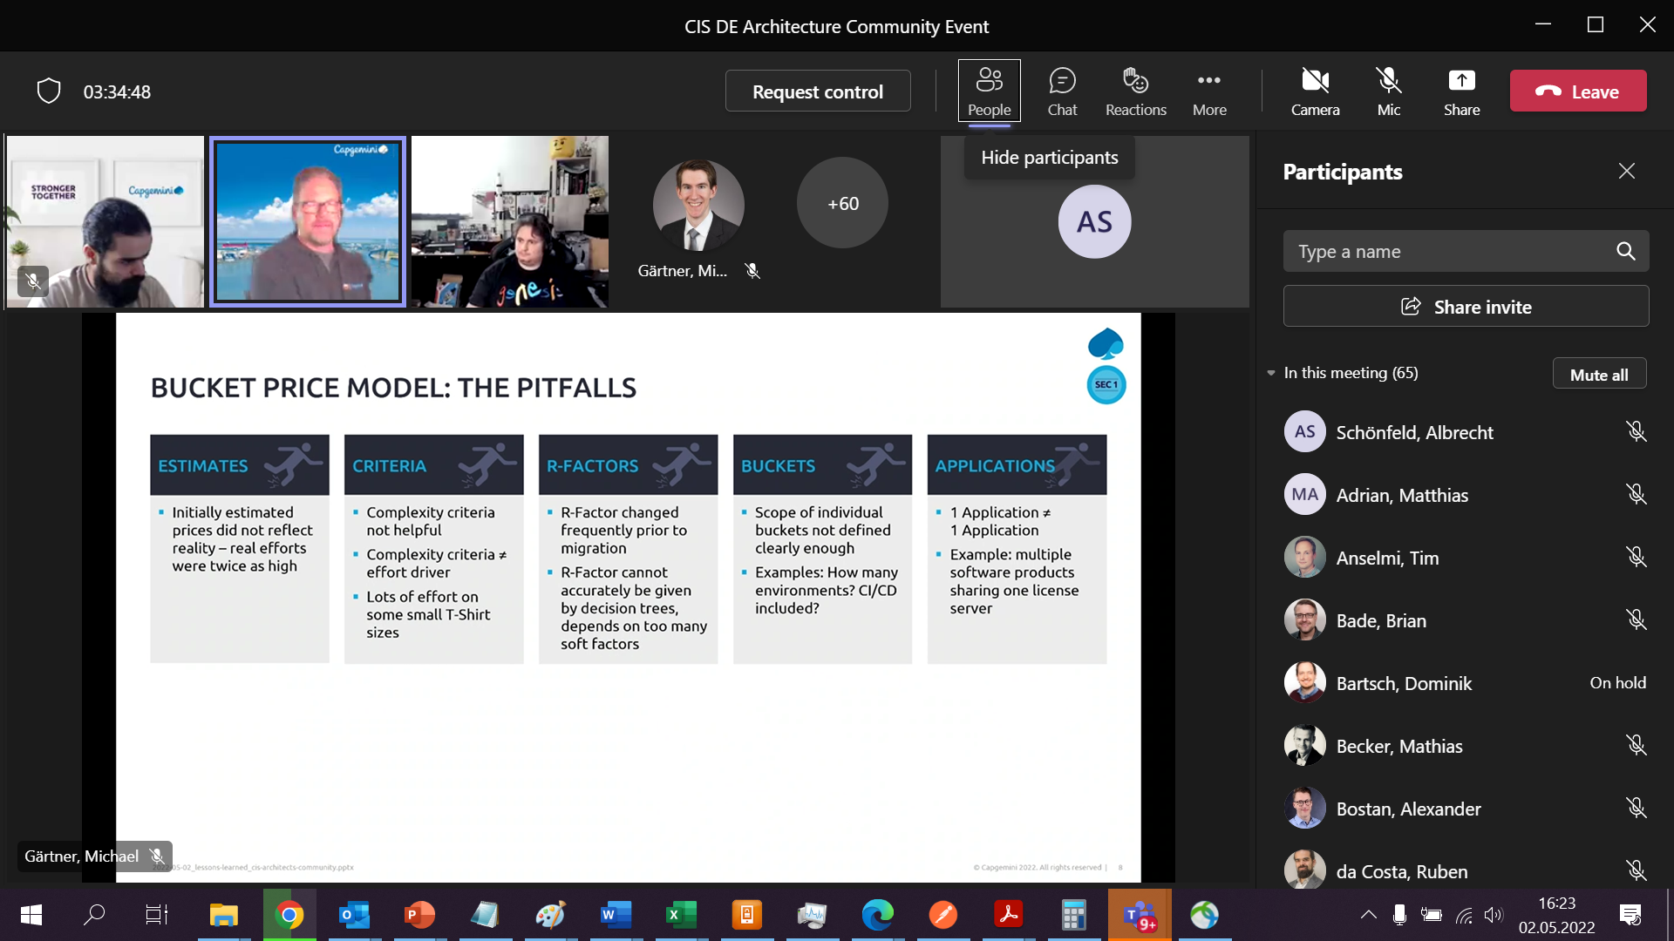

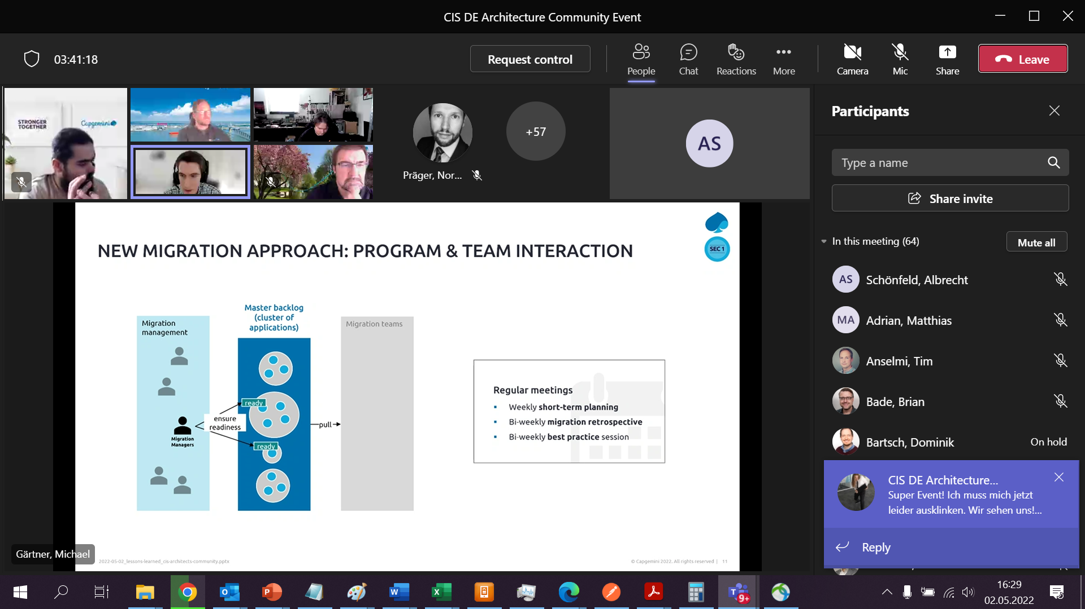

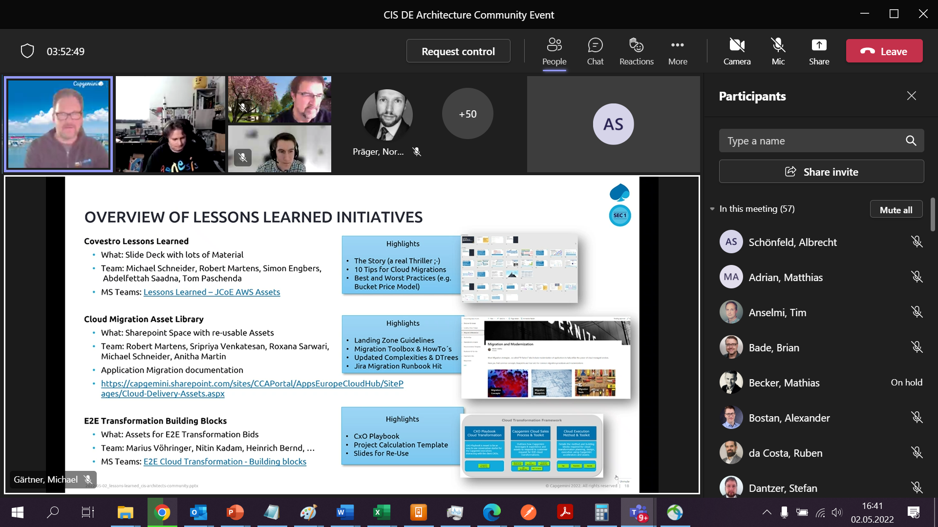

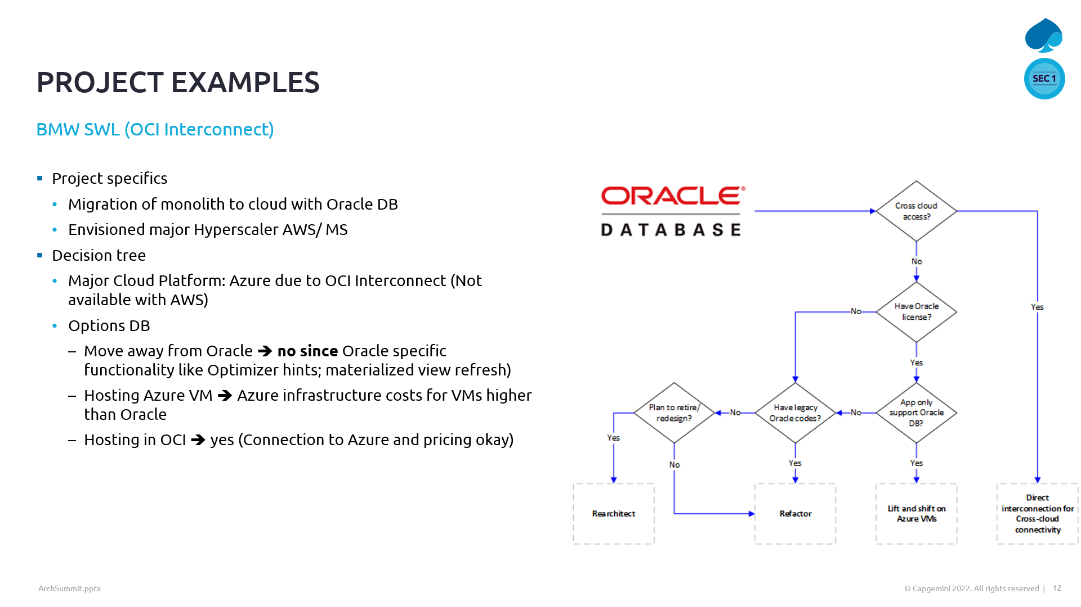

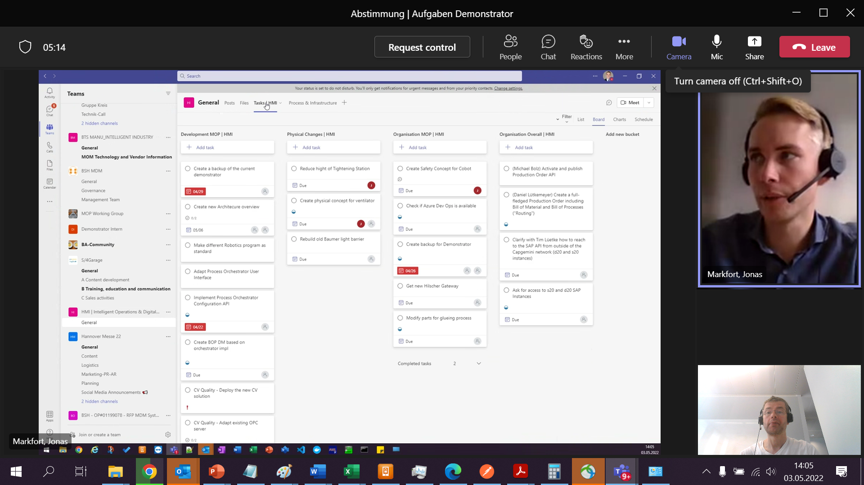

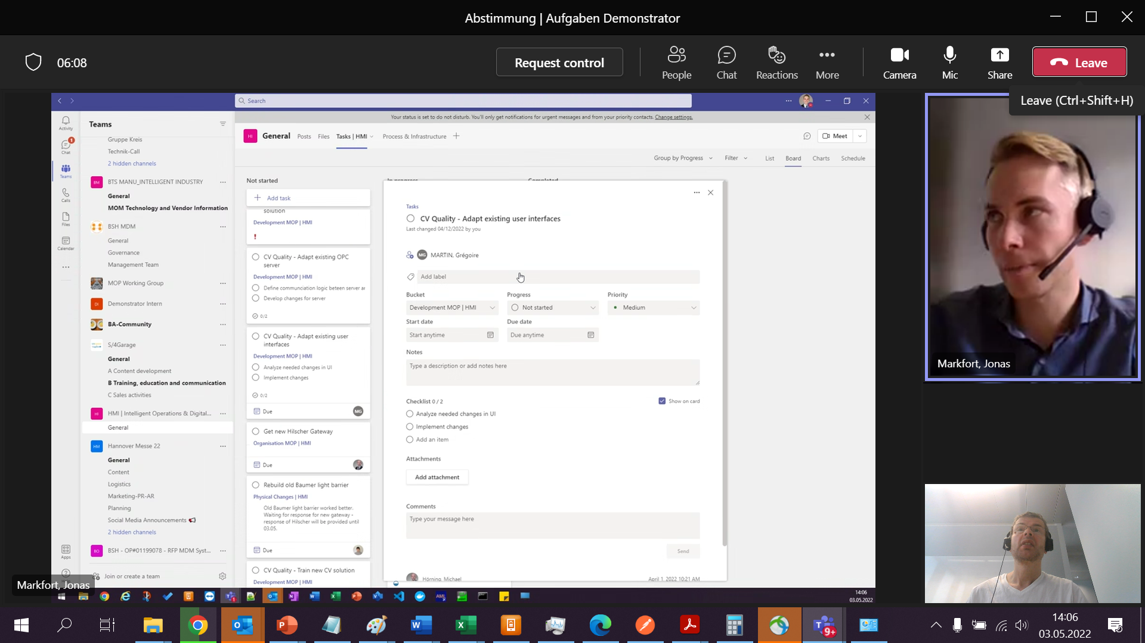

Azure Digital Twin

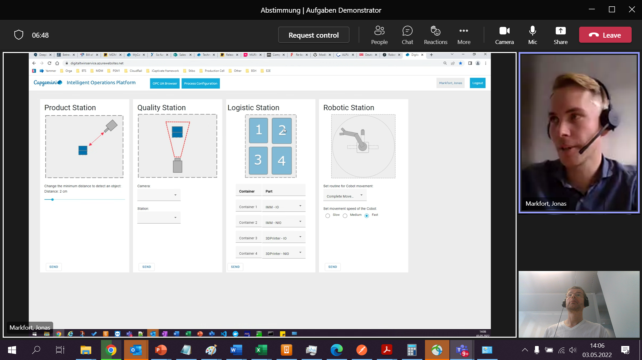einträge ändern: Liste von 4 auf 2 Container; Einträge Dropdown ändern;

App service web app (dashboards anpassen)

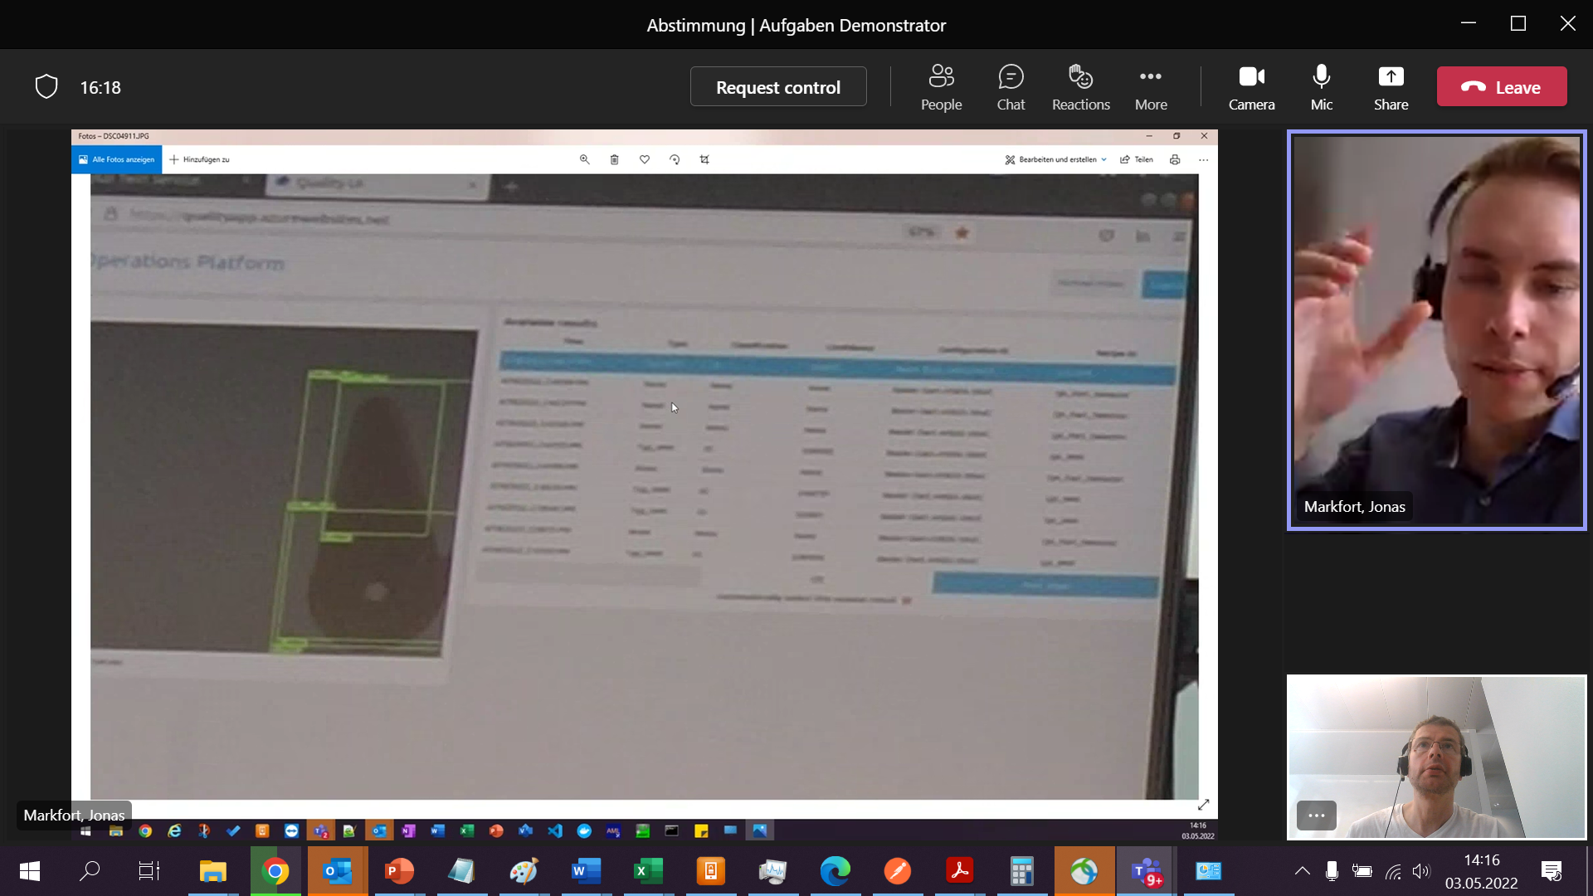

Anpassen

16-20.Mai Test

Entwickeln: diese Woche und nächste Woche

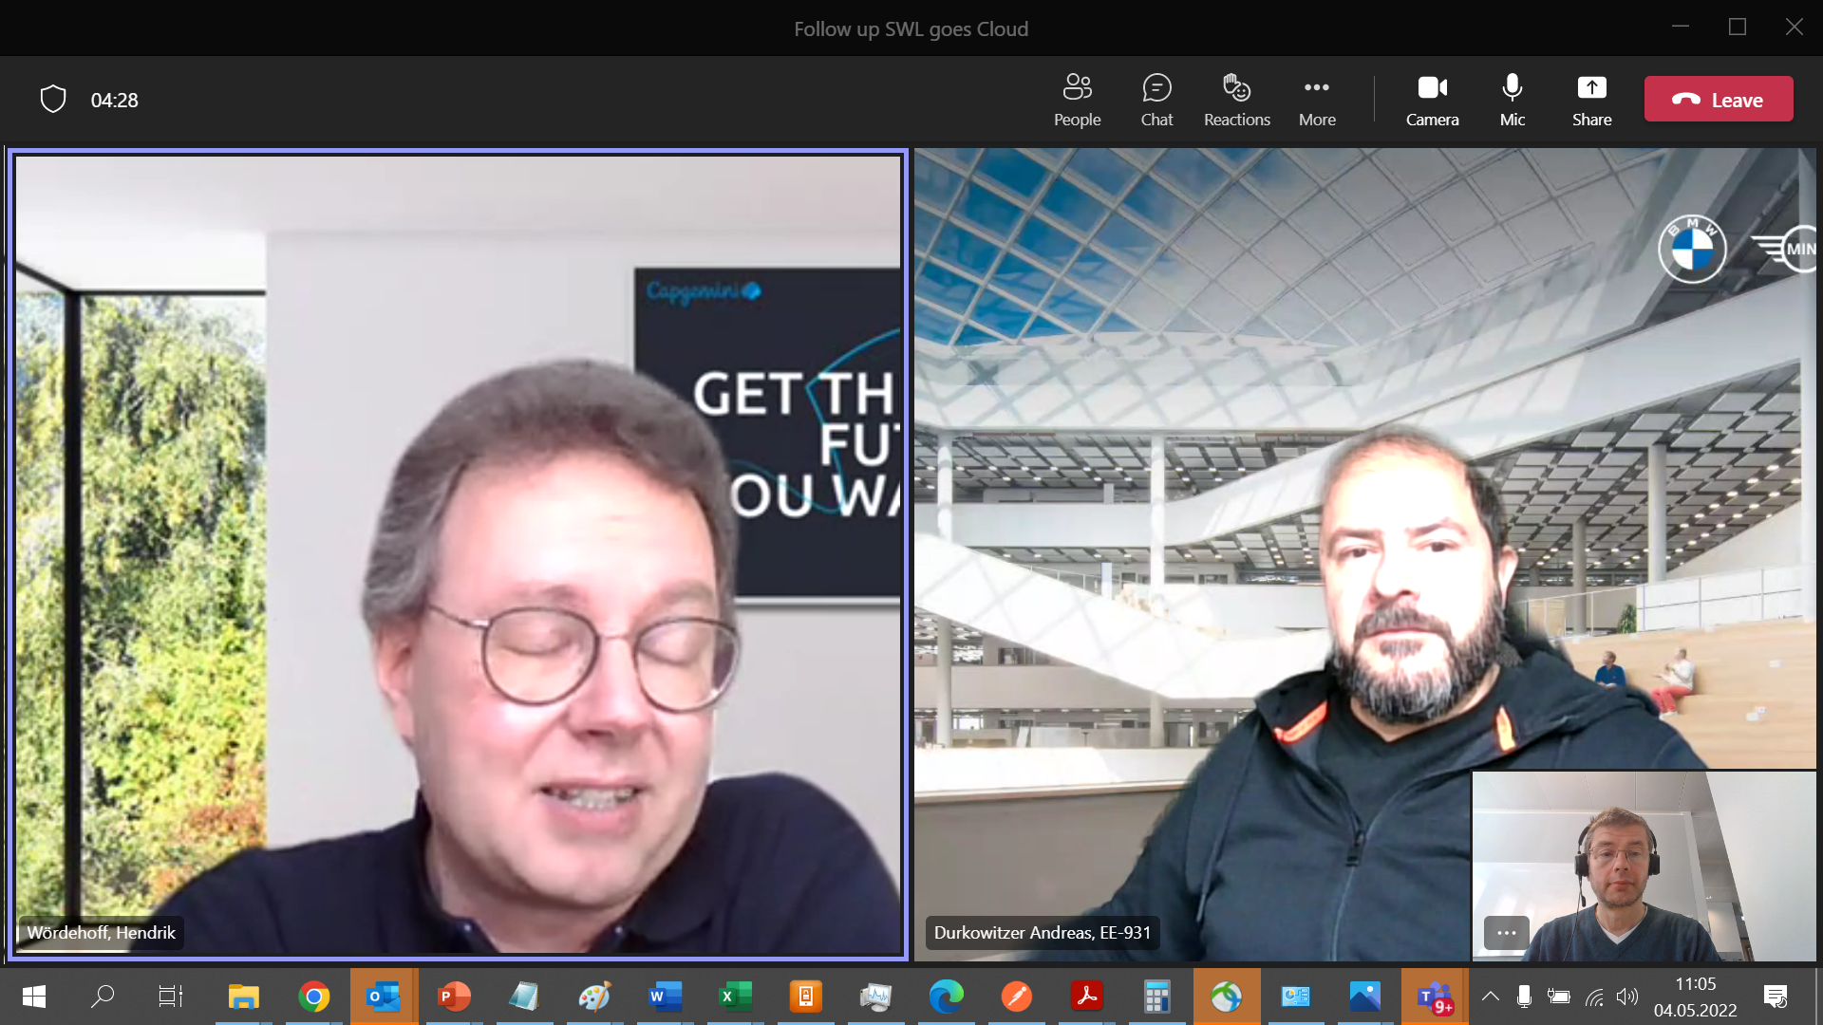

RUDI = System in Cloud OpenStack, mit dem wir Daten austauschen

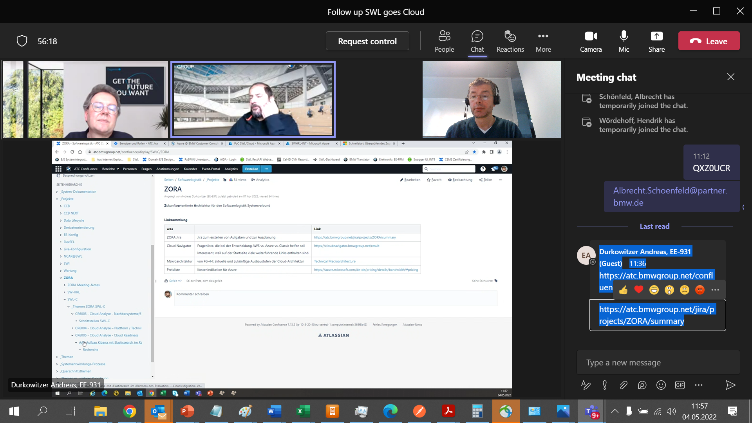

Wohin gehen die Schnittstellenpartner

Vorbereitend machen

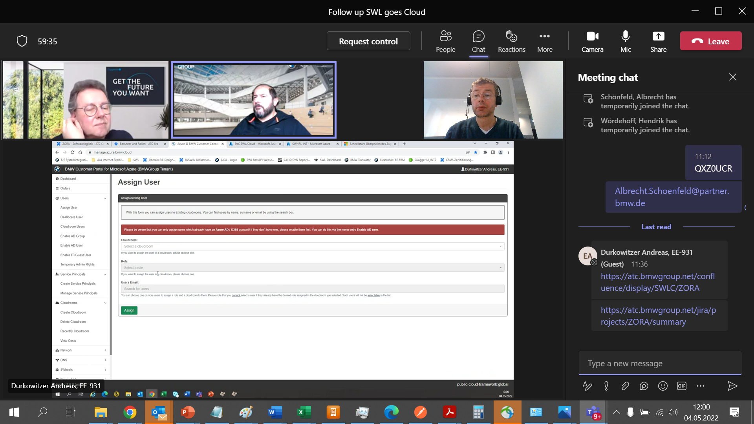

Email auf die BMW-Adresse

Wie aufsetzen - Netzwerkressourcen/ resource group

Anlegen lassen

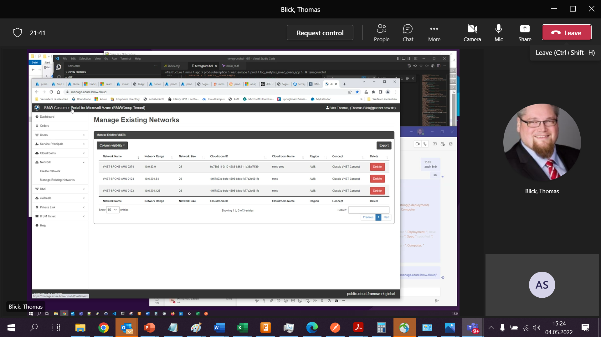

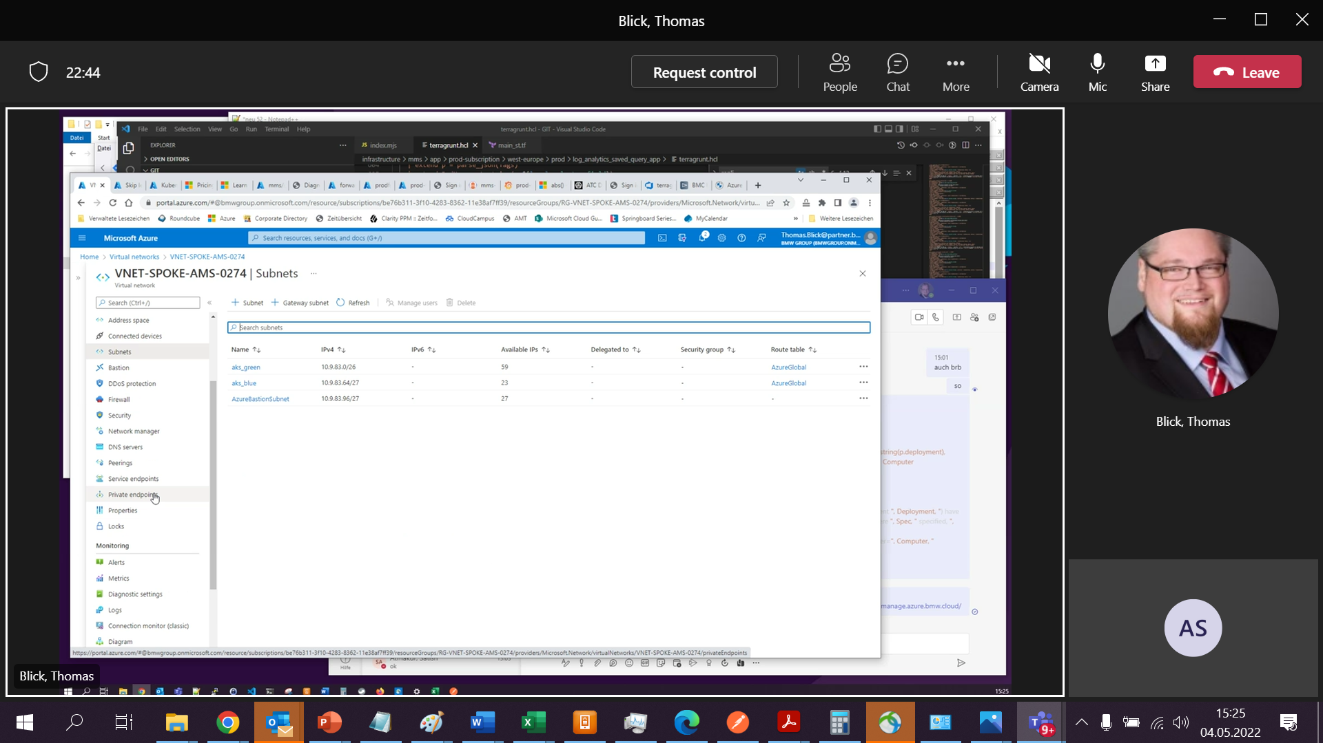

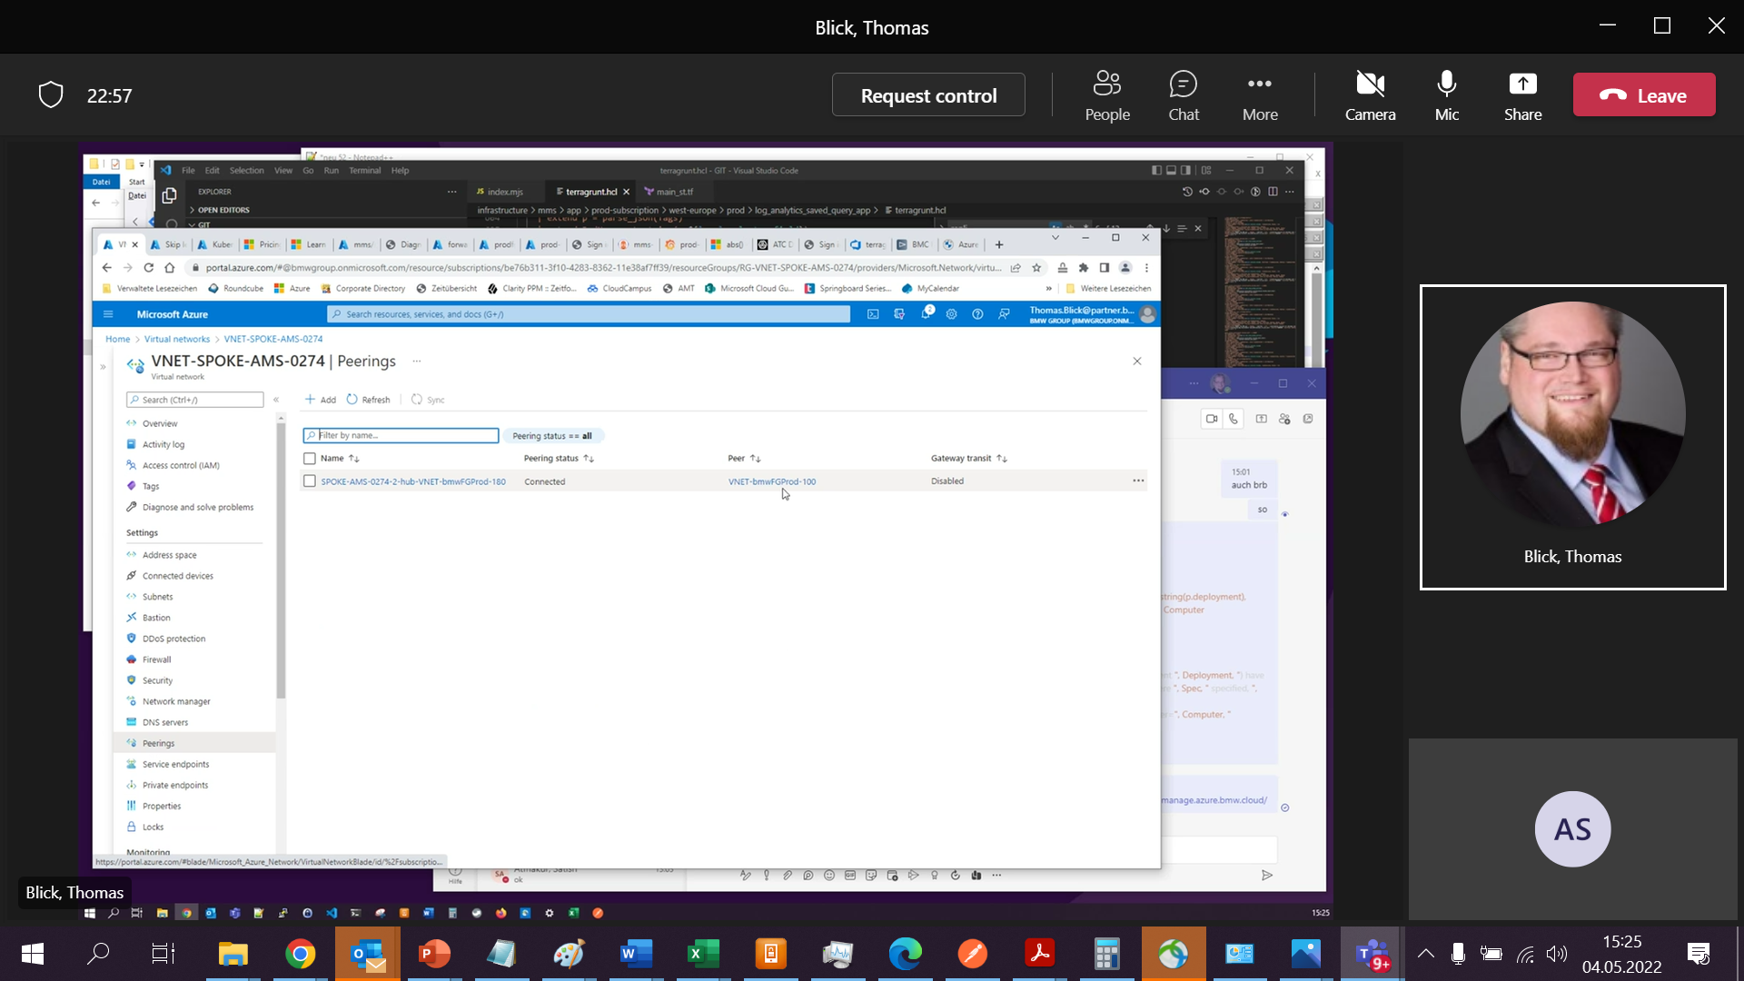

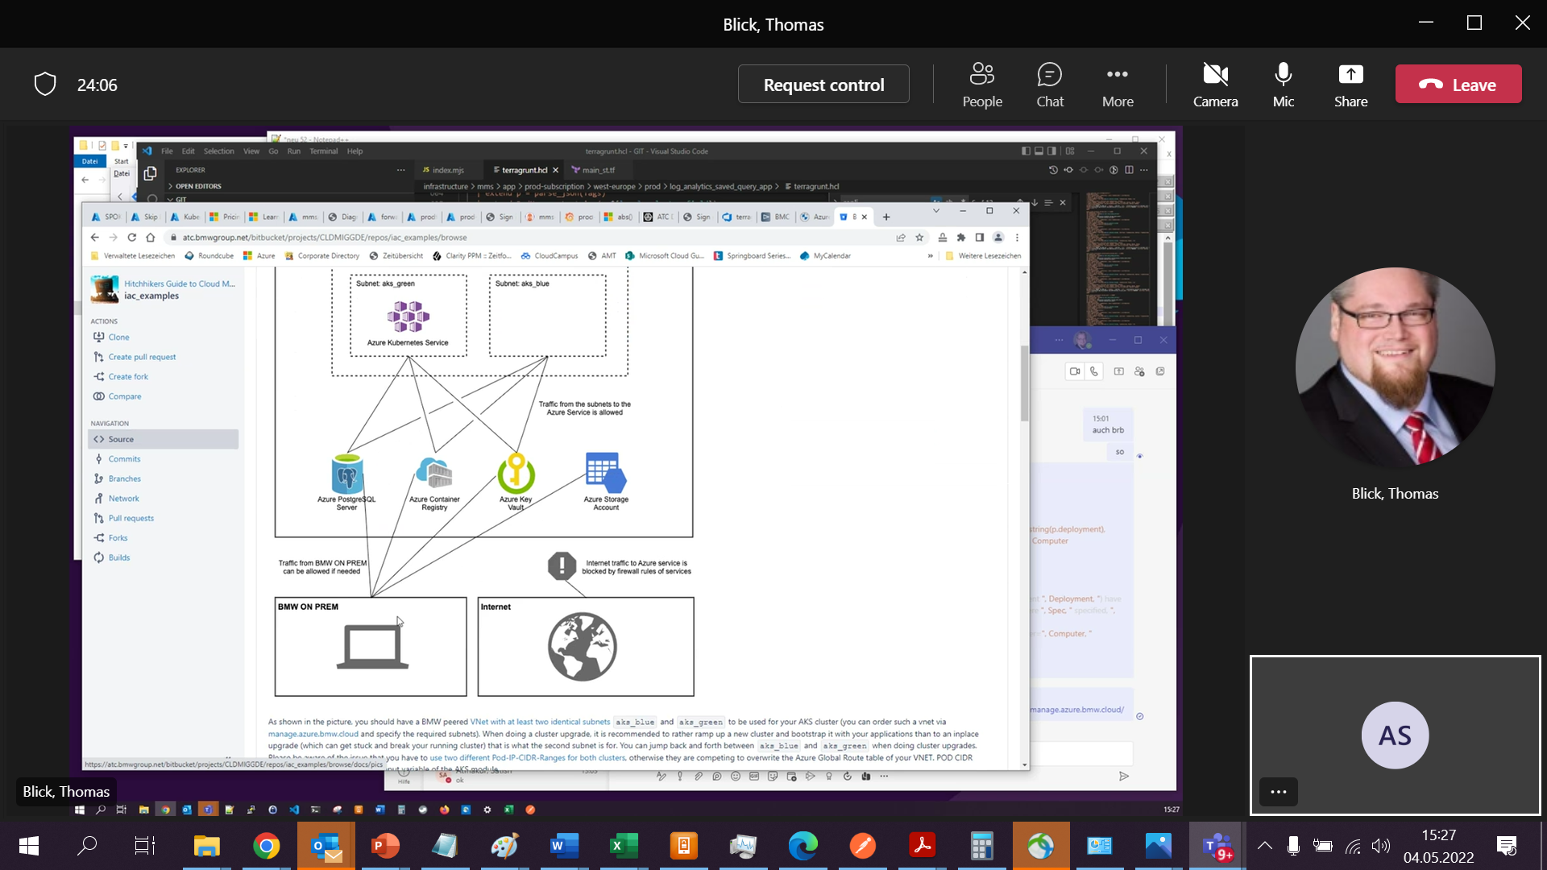

ACR public öffentlich auf IP-Range

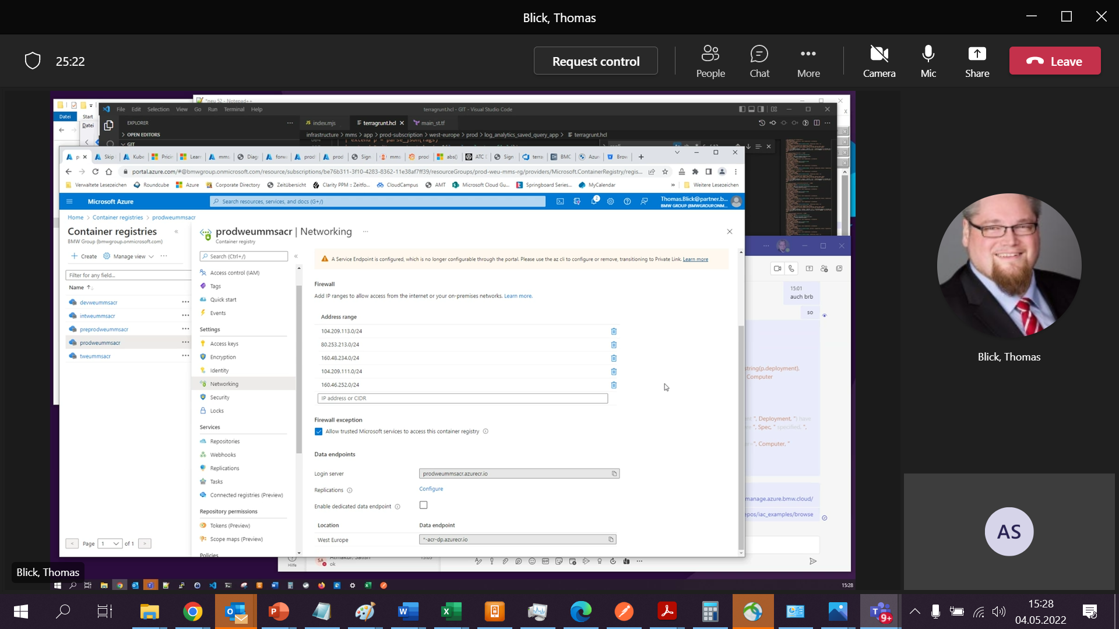

* Expose as alarm in Oracle

Push Method => Authentication problemtic

* + <https://technology.amis.nl/oracle-cloud/use-oci-monitoring-alarms-and-notifications-for-your-own-custom-and-functional-metrics/>
  + Check whether something different possible then Email => even then authentication Azure is probably problematic
* Instrument database with Azure Arch agent
  + So far nothing found => probably difficult
* Polling from Azure in regular intervals
  + **=> So far recommended method**
  + Solves authentication via interconnect
  + Database
    - probably possible with a dedicated view providing health information
    - Making request from Azure side

KV002-full => Internet range

KV002 =>

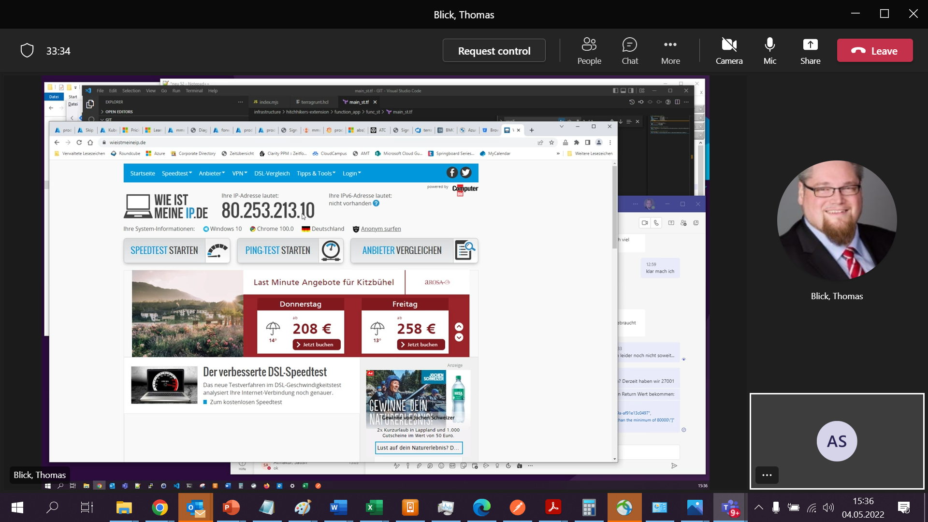

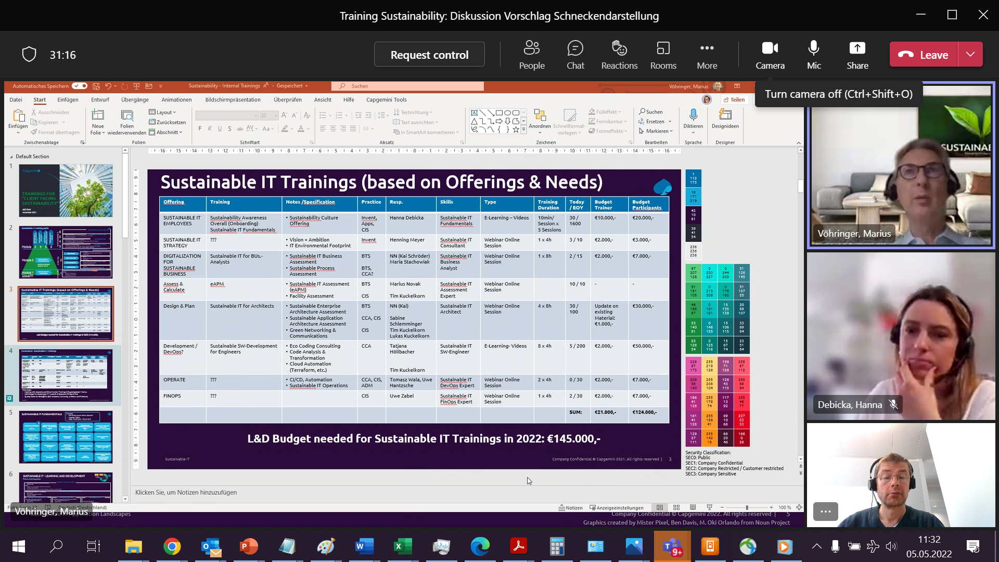

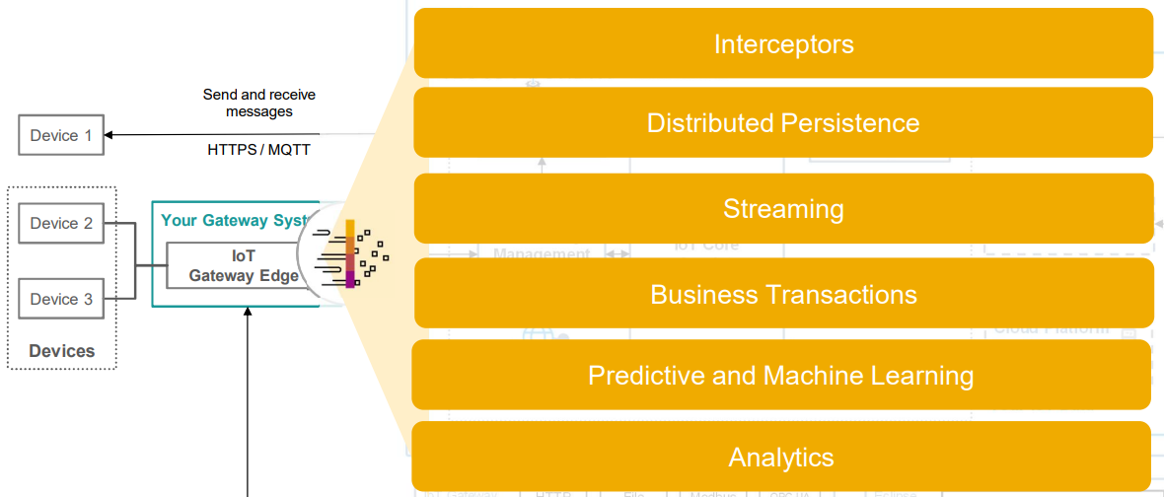

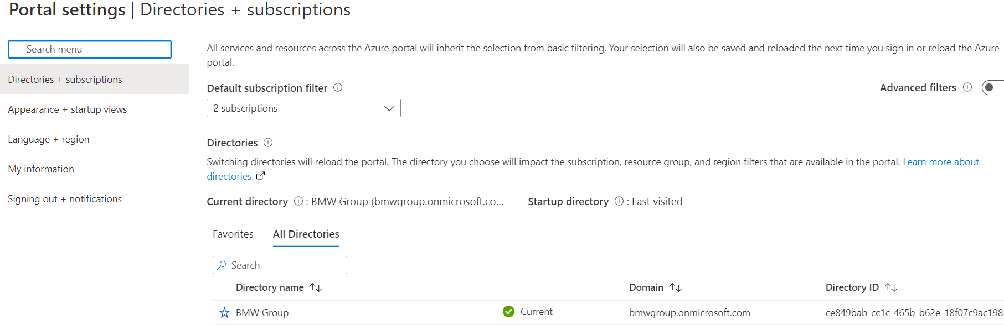

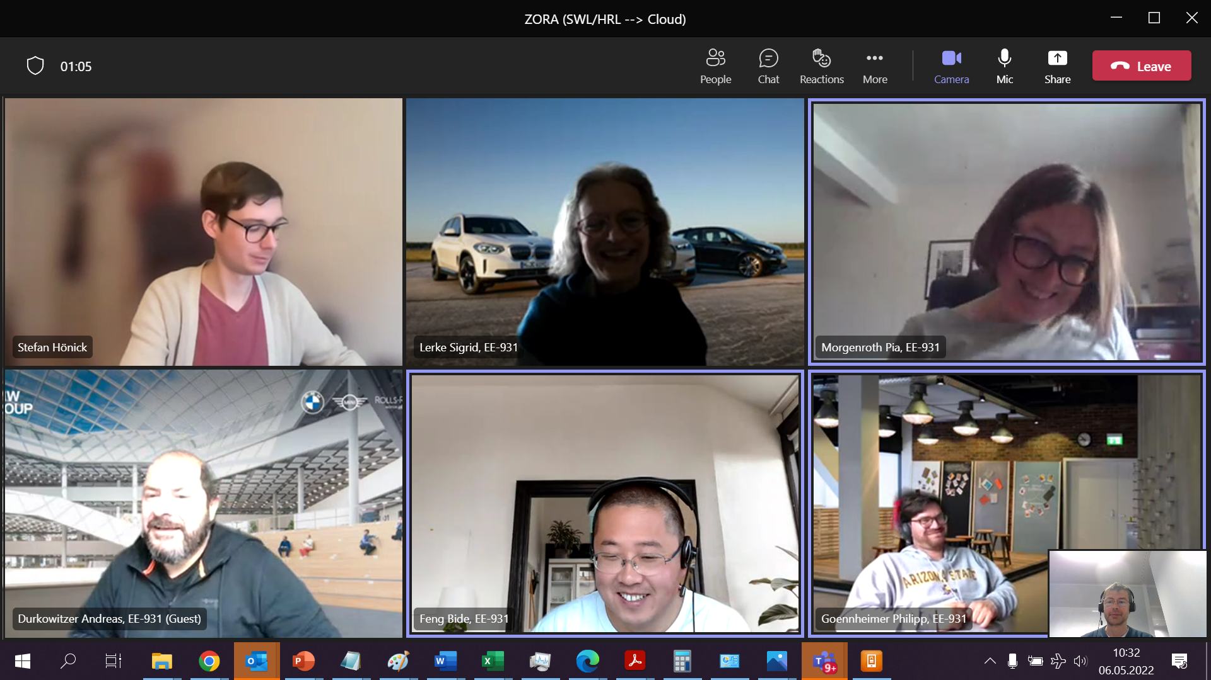

Gesprochen mit Stefan Pechstein

* EJB Container
* Container
* CPT Modul

